Macintosh HD:Users:cem:xeniC:embedded:Projects:Universal Naza CAN Bus Telemetrie Adapter:Documentation:AnySense Pfeile CMYK-weiss.epsMacintosh HD:Users:cem:xeniC:embedded:Projects:Universal Naza CAN Bus Telemetrie Adapter:Documentation:AnySense CMYK-weiss.eps

Firmware version: 1.2

Operating Manual

asdsad

Macintosh HD:Users:cem:xeniC:embedded:Projects:Universal Naza CAN Bus Telemetrie Adapter:Documentation:CE-WEEE CMYK-schwarz.eps

Disposal of old devices

The symbol below indicates that this product must be disposed of separately from household waste; take it to an authorised collection centre. The separate collection and recycling of the product conserves reserves of raw materials and ensures compliance with all regulations governing the protection of heath and the environment.

Declaration of conformity

xeniC UG (limited liability) hereby declares that the product conforms to the fundamental requirements and other relevant provisions of the applicable CE directives.

Macintosh HD:Users:cem:xeniC:embedded:Projects:Universal Naza CAN Bus Telemetrie Adapter:Documentation:Logo_xeniC.eps

xeniC UG (limited liability)

Poelchaukamp 7b

D-22301 Hamburg, Germany

Telephone: +49 (0) 40 325 923 68

WEEE reg. No. DE 39058794

<http://www.anysense.de>

Foreword 2

Description 2

Scope of operation 3

1 Available data 3

2 Display on the telemetry systems 5

2.1 Futaba S.Bus2 5

2.2 Graupner/SJ HoTT 6

2.3 Jeti Duplex EX 7

2.4 FrSky S.Port 8

3 FrSky sensors add-ons 9

4 Add-ons with MAVLink components (MinimOSD) 9

Initial operation 12

1. Connection with the DJI 12

1.1. Naza M V1/V2 13

1.2. Wookong M 14

1.3. Phantom 1 15

1.4. Phantom 2 16

2. Select telemetry system 16

2.1. Selection of the remote control 16

2.2. Selection with the Configuration Manager 17

3. Connect with the telemetry system 19

3.1. Futaba S.Bus2 20

3.2. Graupner/SJ HoTT 21

3.3. Jeti Duplex EX 21

3.4. FrSky S.Port 22

4. Troubleshooting 23

Advanced configuration 25

1. Configuration Manager 25

2. Firmware update 26

3. Telemetry system 26

3.1. Futaba S.Bus2 27

3.2. Graupner/SJ HoTT 28

3.3. Jeti Duplex EX 29

3.4. FrSky S.Port (Taranis) 29

4. Further instructions 31

4.1. LED status 31

# Foreword

Thank you for choosing our product. Please read carefully through the following instructions in order to correctly install and connect the device. Please also visit our homepage regularly at <http://www.anysense.de>. The latest product information, what's new, technical updates and revisions to the instructions can all be found here. If you have any questions regarding your product, please contact your specialist dealer or AnySense customer service.

# Description

The AnySense telemetry module has been specially designed to be used with DJI flight control systems. The AnySense can supply telemetry information in real time to provide you with all status information about your multicopter during a flight.

In the case of an unintended landing or a flight controller malfunction, the AnySense will display the current position at all times.

Therefore the last known position will be shown on the remote control display, even in the case of a complete failure.

In addition to the display, all data will also be saved on the storage card of your remote control. With the right tools, you can easily visualise the content of the storage card, export it to Excel or even embed it into existing videos.

With the support of the MAVLink protocol, the AnySense adapts the disparity between the standard protocol that is widespread in the multicopter segment and the DJI products.

Thus DJI pilots also gain access to many add-ons and expert functions that were previously only available for other flight controllers.

This makes it possible for example for the much more flexible minimOSD to also be operated with the Naza, Phantom or also the Wookong.

# Scope of operation

## Available data

All flight data from the DJI flight controller is available to the AnySense via the CAN bus. The following list describes all of the information available. Please refer to Chapter 2 – Display on the telemetry systems for information on how these are displayed in your telemetry system.

* **Position**  
  Latitude and longitude of the current position of the multicopter. These are also retained in an emergency to ensure that the position of the multicopter can also be determined in the case of radio/power failure.
* **RTH/failsafe home position**  
  The home position of the Naza is approached in failsafe or coming home function. This position is also used to calculate other information, such as distance or home direction.
* **GPS satellites**  
  The number of satellites determines the signal quality of the GPS reception. The greater the number of satellites that are visible, the more precisely the position is determined.
* **GPS fix**

0: No determination of position possible

2: Two dimensional determination of position

3: Three dimensional determination of position (including altitude)

4: Differential GPS: geostationary satellites are received, which enable very precise determination of position.

* **Speed**  
  Speed in km/h based on the GPS position change. Therefore, only possible with adequate GPS signal.
* **Distance**  
  Distance in metres to the home position defined by the flight controller.
* **Compass (in degrees)**  
  The compass provides the tilt-compensated line of sight (arrow on GPS antenna) of the multicopter in degrees.
* **Flight direction**   
  The flight direction of the multicopter in degrees. This value can differ from the line of sight and is calculated based on the GPS position change.
* **Home direction**  
  The direction of the home position defined by the flight controller in degrees.
* **Flight mode**  
  The current flight mode of the multicopter:  
  0: Manual  
  1: GPS  
  2: Failsafe  
  3: Atti.
* **Altitude**  
  Exact altitude in metres as measured by the barometric sensor. This is more precise compared with the GPS-based altitude.
* **Variometer**  
  Multicopter rate of climb and descent.
* **Roll-pitch-yaw angle**  
  The angle of the multicopter, which is used both for the compensated compass and also for the OSD of the artificial horizon.
* **Total voltage**  
  The voltage of the flight battery measured by the flight controller. No calibration is necessary and it provides precise values immediately.
* **Flight time**  
  The precise-to-the-second flight time that starts measuring when the engine is started and ends automatically after stopping.
* **Current [[1]](#footnote-1)**  
  The actual current consumption of the multicopter in amps.
* **Capacity 1**  
  The capacity drawn from the flight battery in mAh.
* **LiPo monitoring 1**  
  Monitoring the individual LiPo cells.

## Display on the telemetry systems

The following sections present the displays on the individual remote controls. Depending on the remote control used, the presentation of the display may differ.

## Futaba S.Bus2

Futaba T14SG

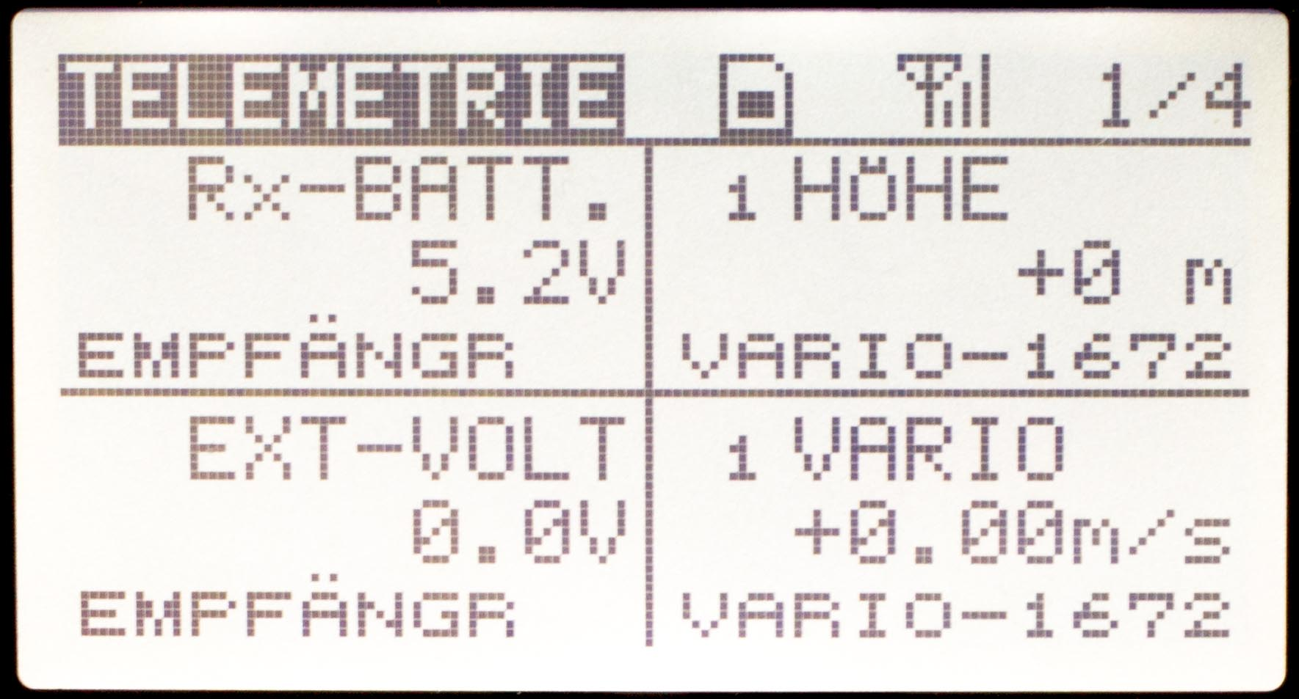 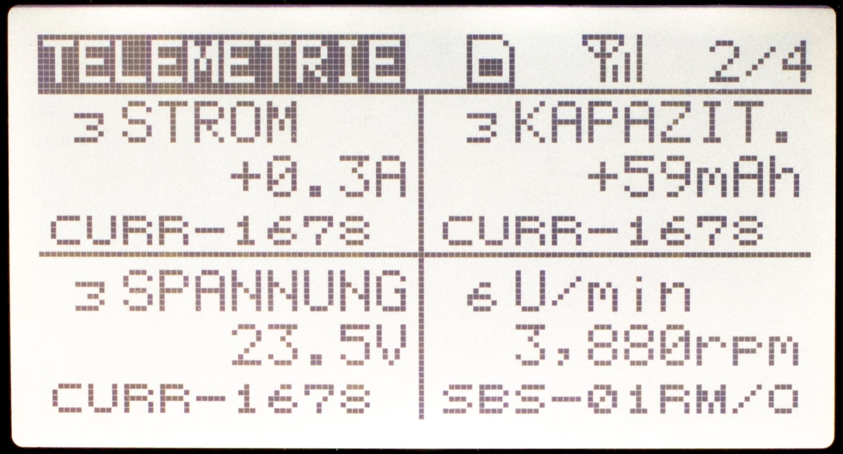

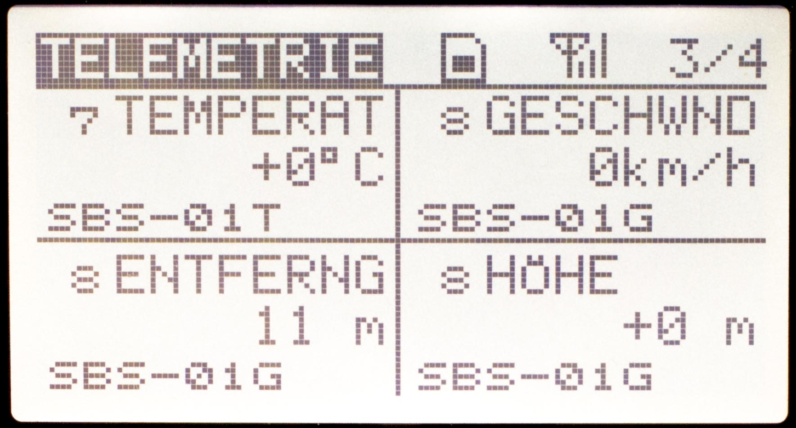 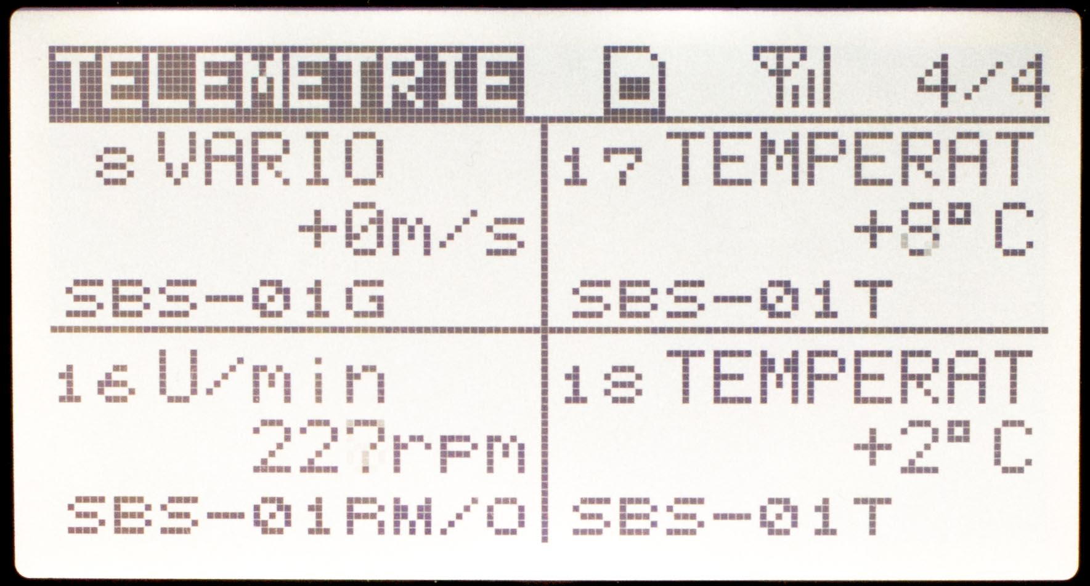

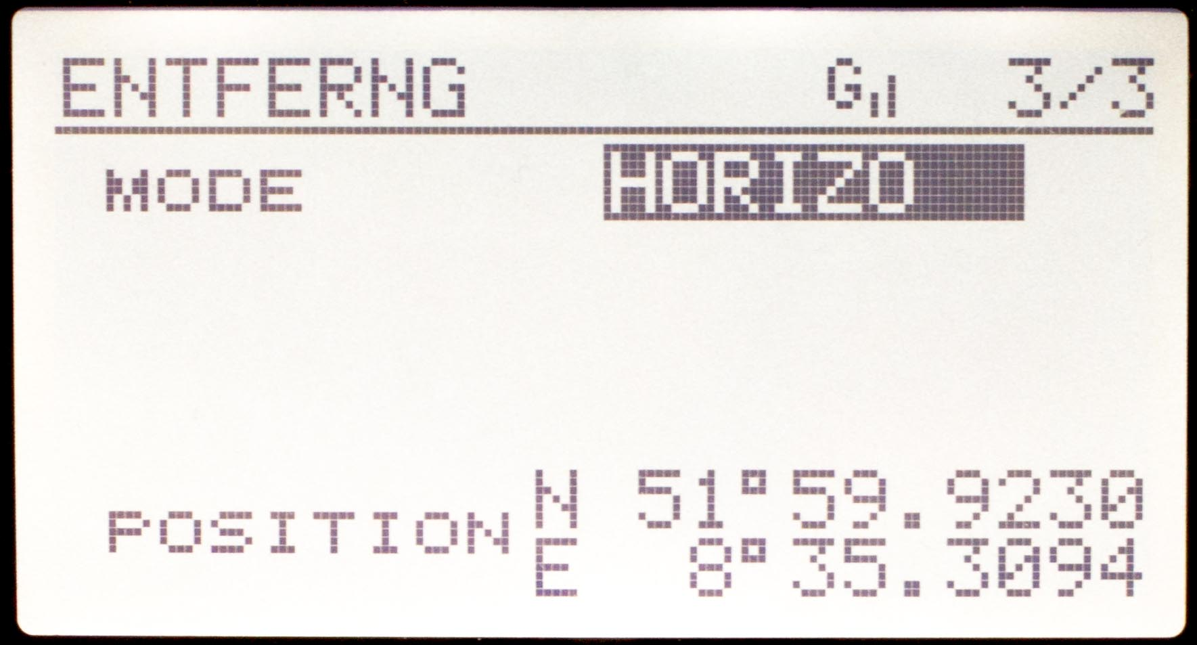

## **Graupner/SJ HoTT**

Graupner MZ-18/24

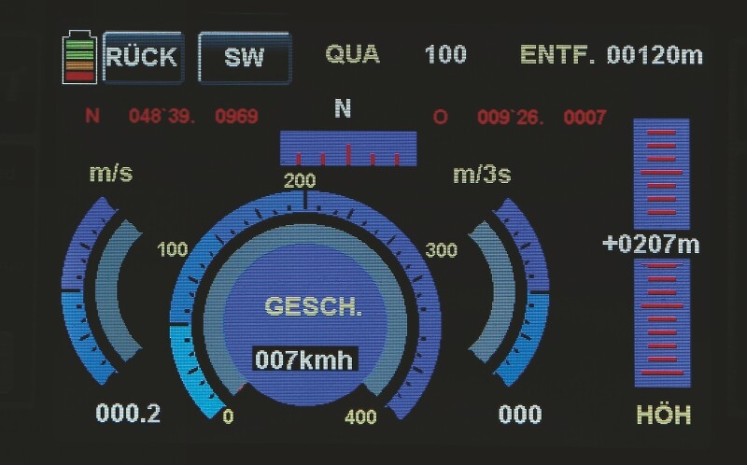 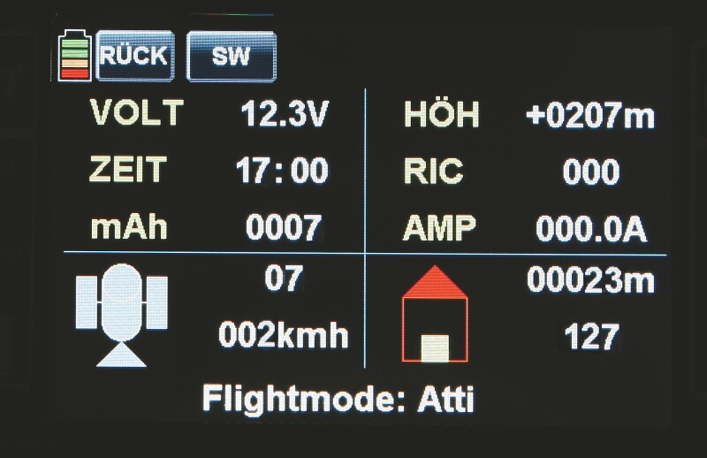

Graupner MX-12/16/20

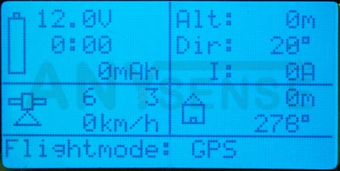 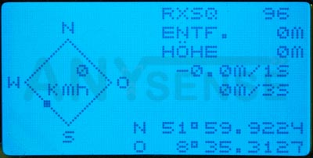

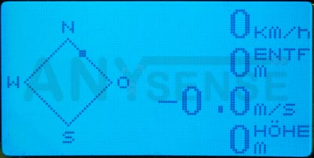 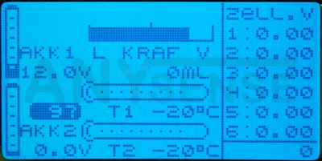

## Jeti Duplex EX

Jeti Box Profi

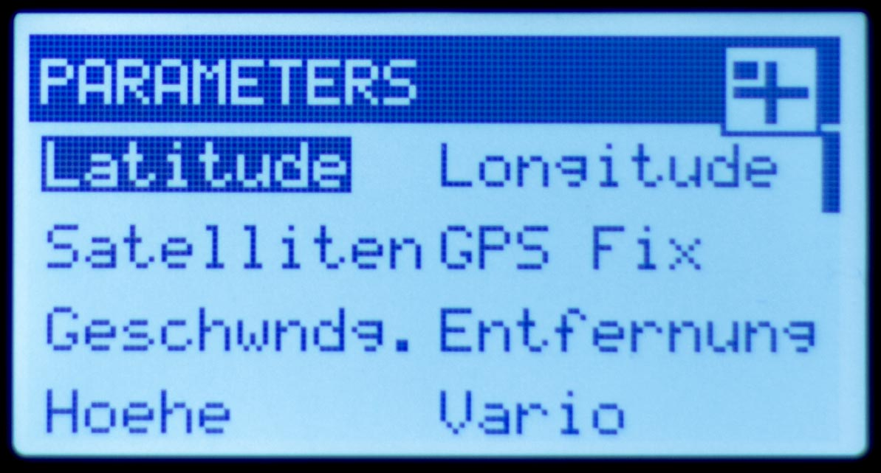 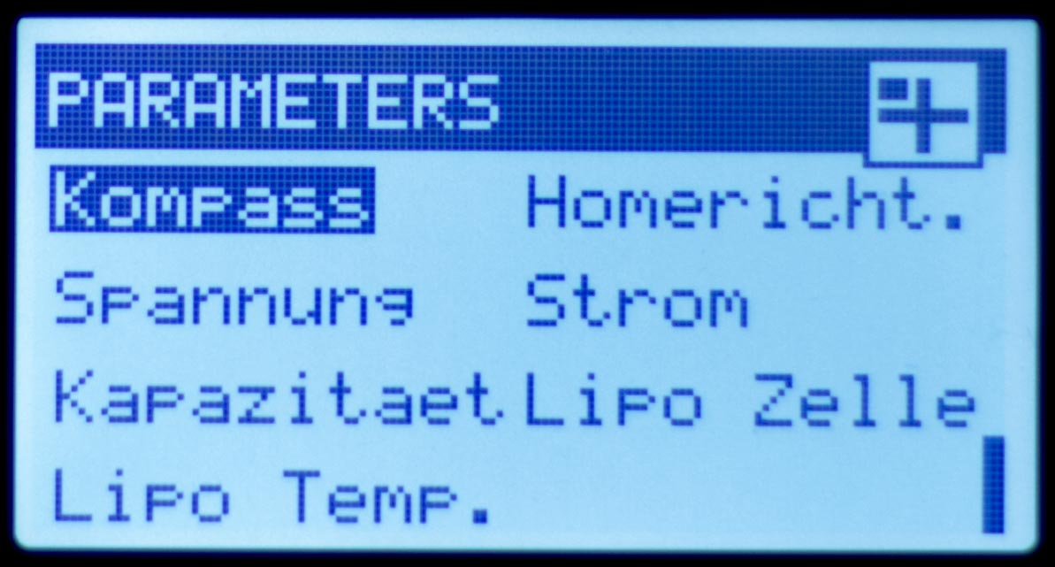

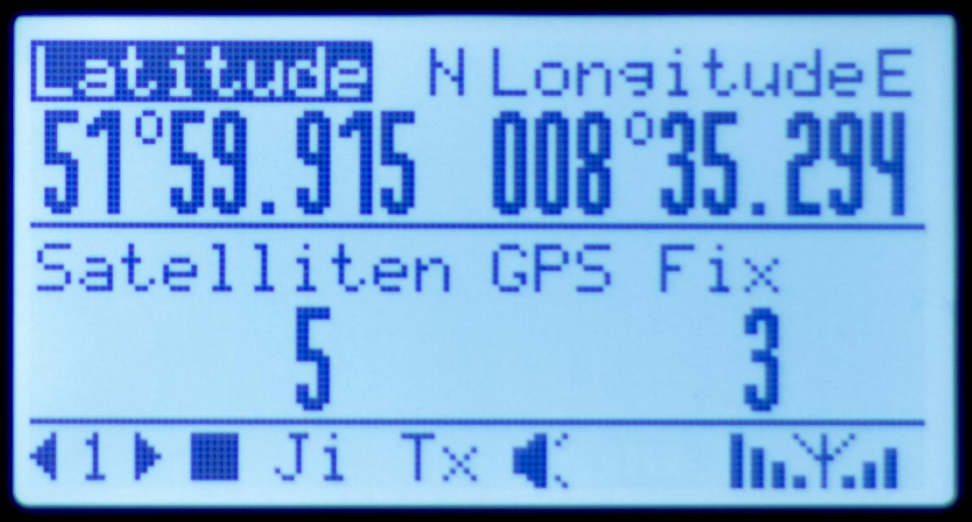 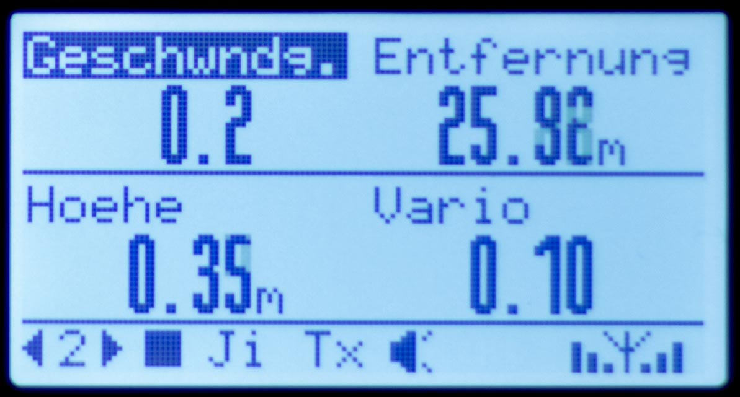

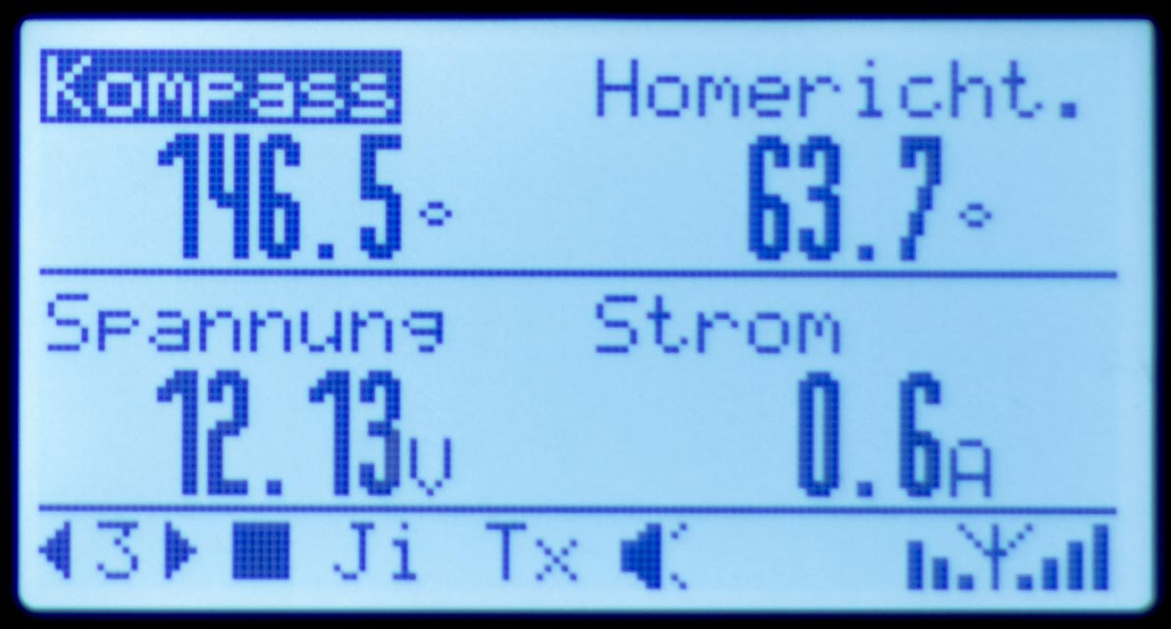 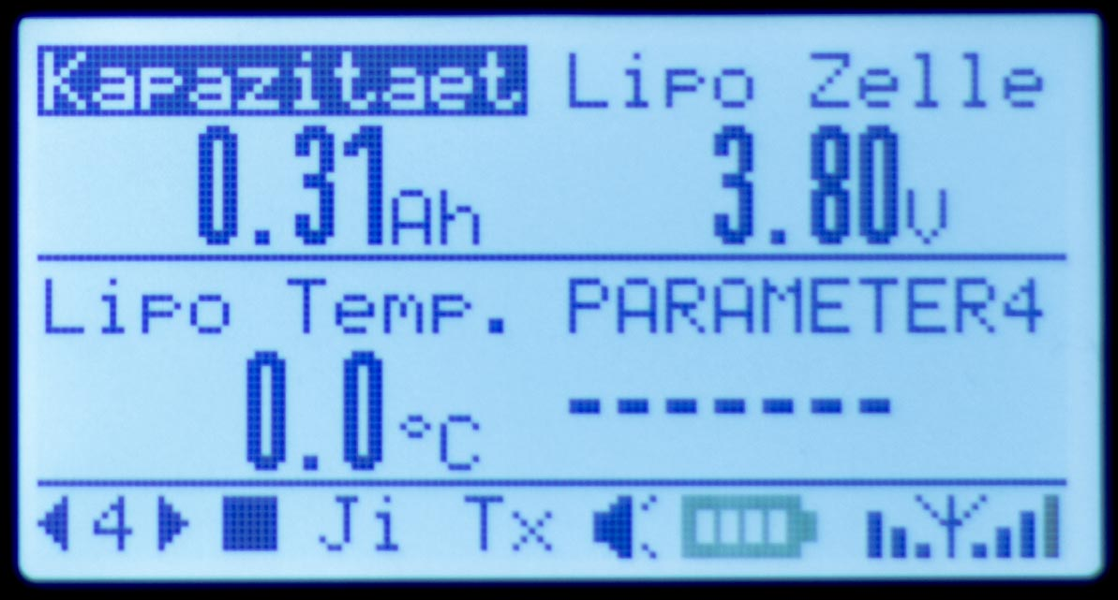

## FrSky S.Port

Taranis / Taranis Plus

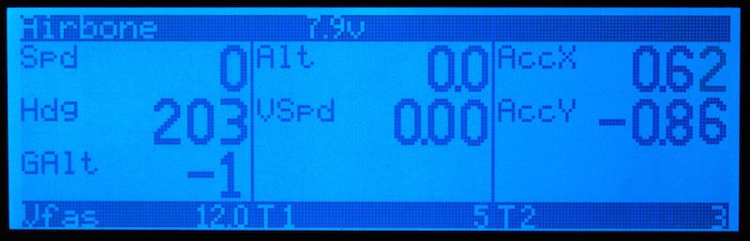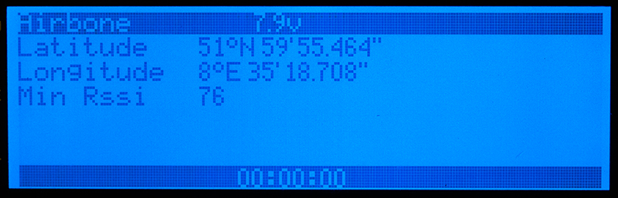

## FrSky sensors add-ons

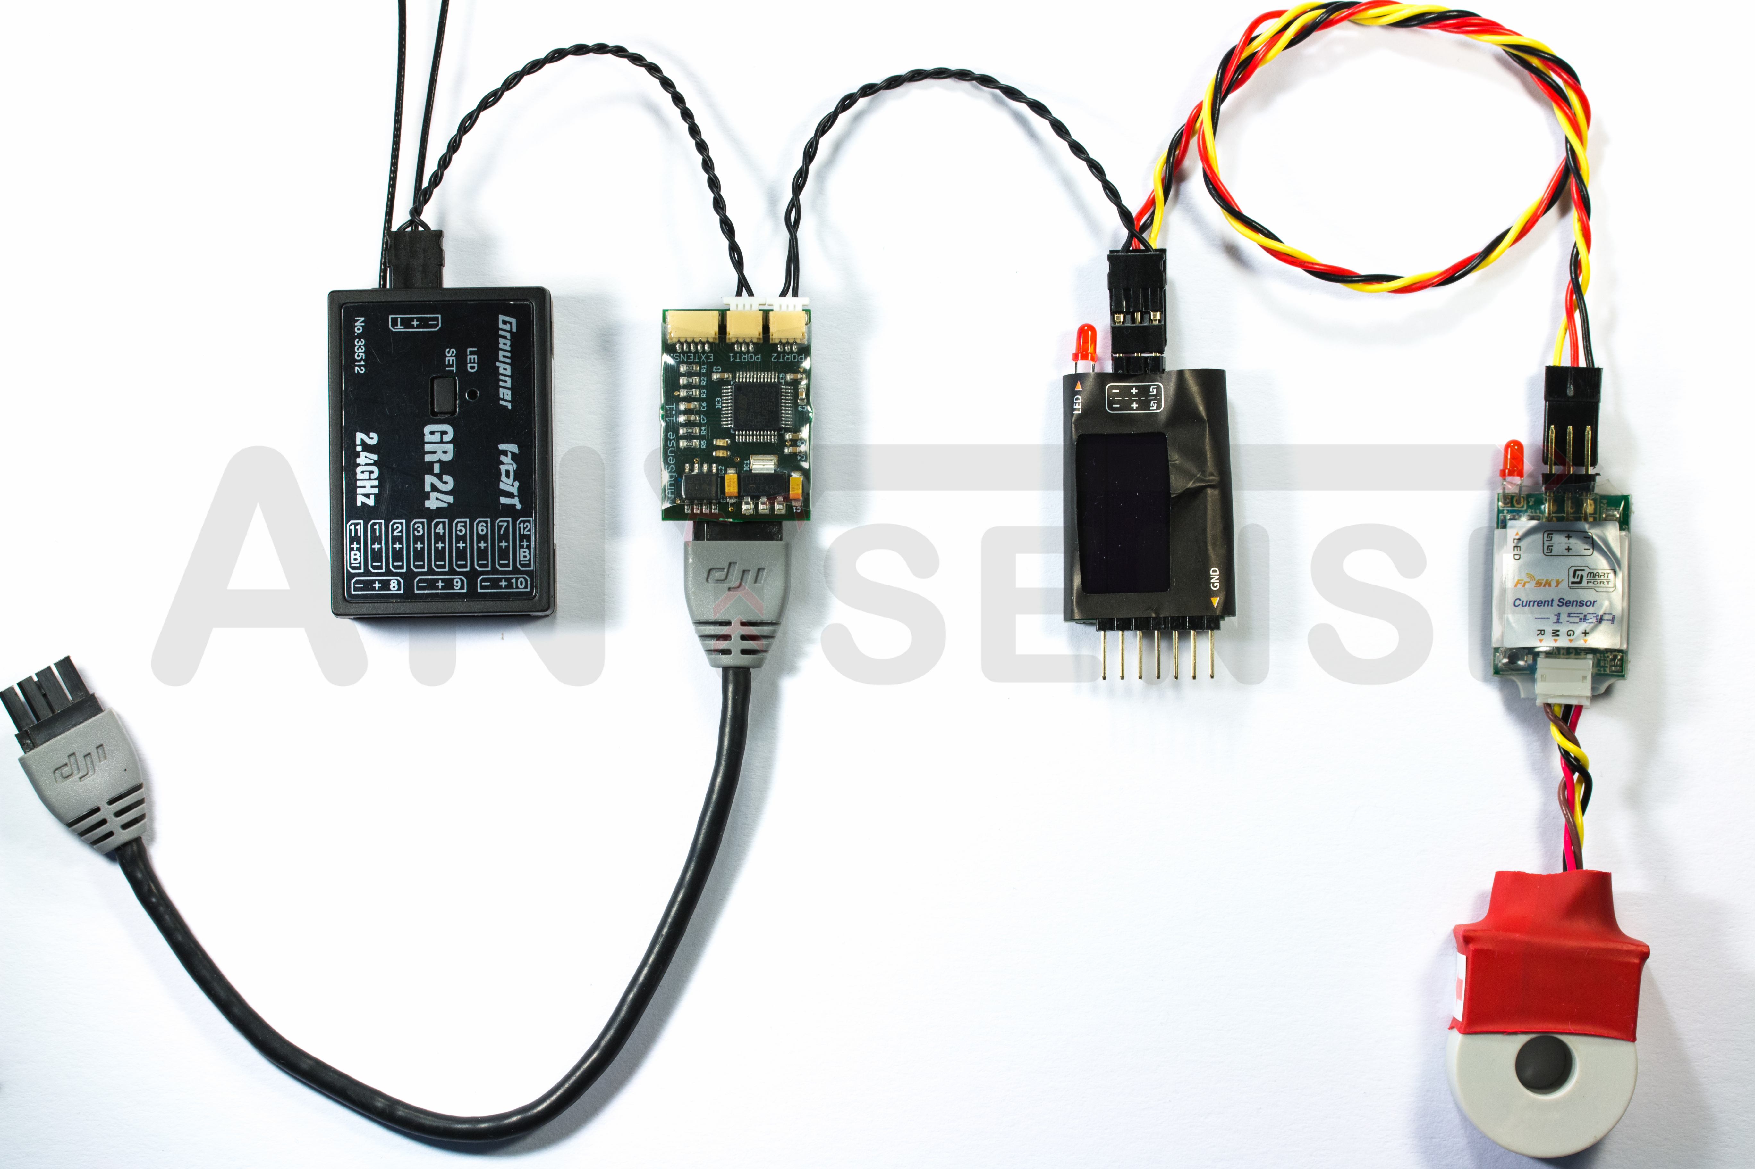As a further useful function, the AnySense allows the value-for-money sensors from the manufacturer FrSky to be connected to the telemetry systems from Graupner/SJ, Futaba, Jeti and MAVLink.

Thereby, the sensor data of the following FrSky sensors are prepared for the Futaba S.Bus2, Jeti Duplex EX, Graupner/SJ HoTT or MAVLink and correspondingly transmitted to your remote control.

* LiPo sensors (FrSky FLVSS)
* Current sensor 40 A (FrSky FCS-40)
* Current sensor 150 A (FrSky FCS-150)

Up to 12 cells and more can be measured by using several LiPo sensors.

At the same time several current sensors can also be connected in order to be able to measure currents above 150A.

Each sensor must be assigned its own ID when using several of the same type of sensors.

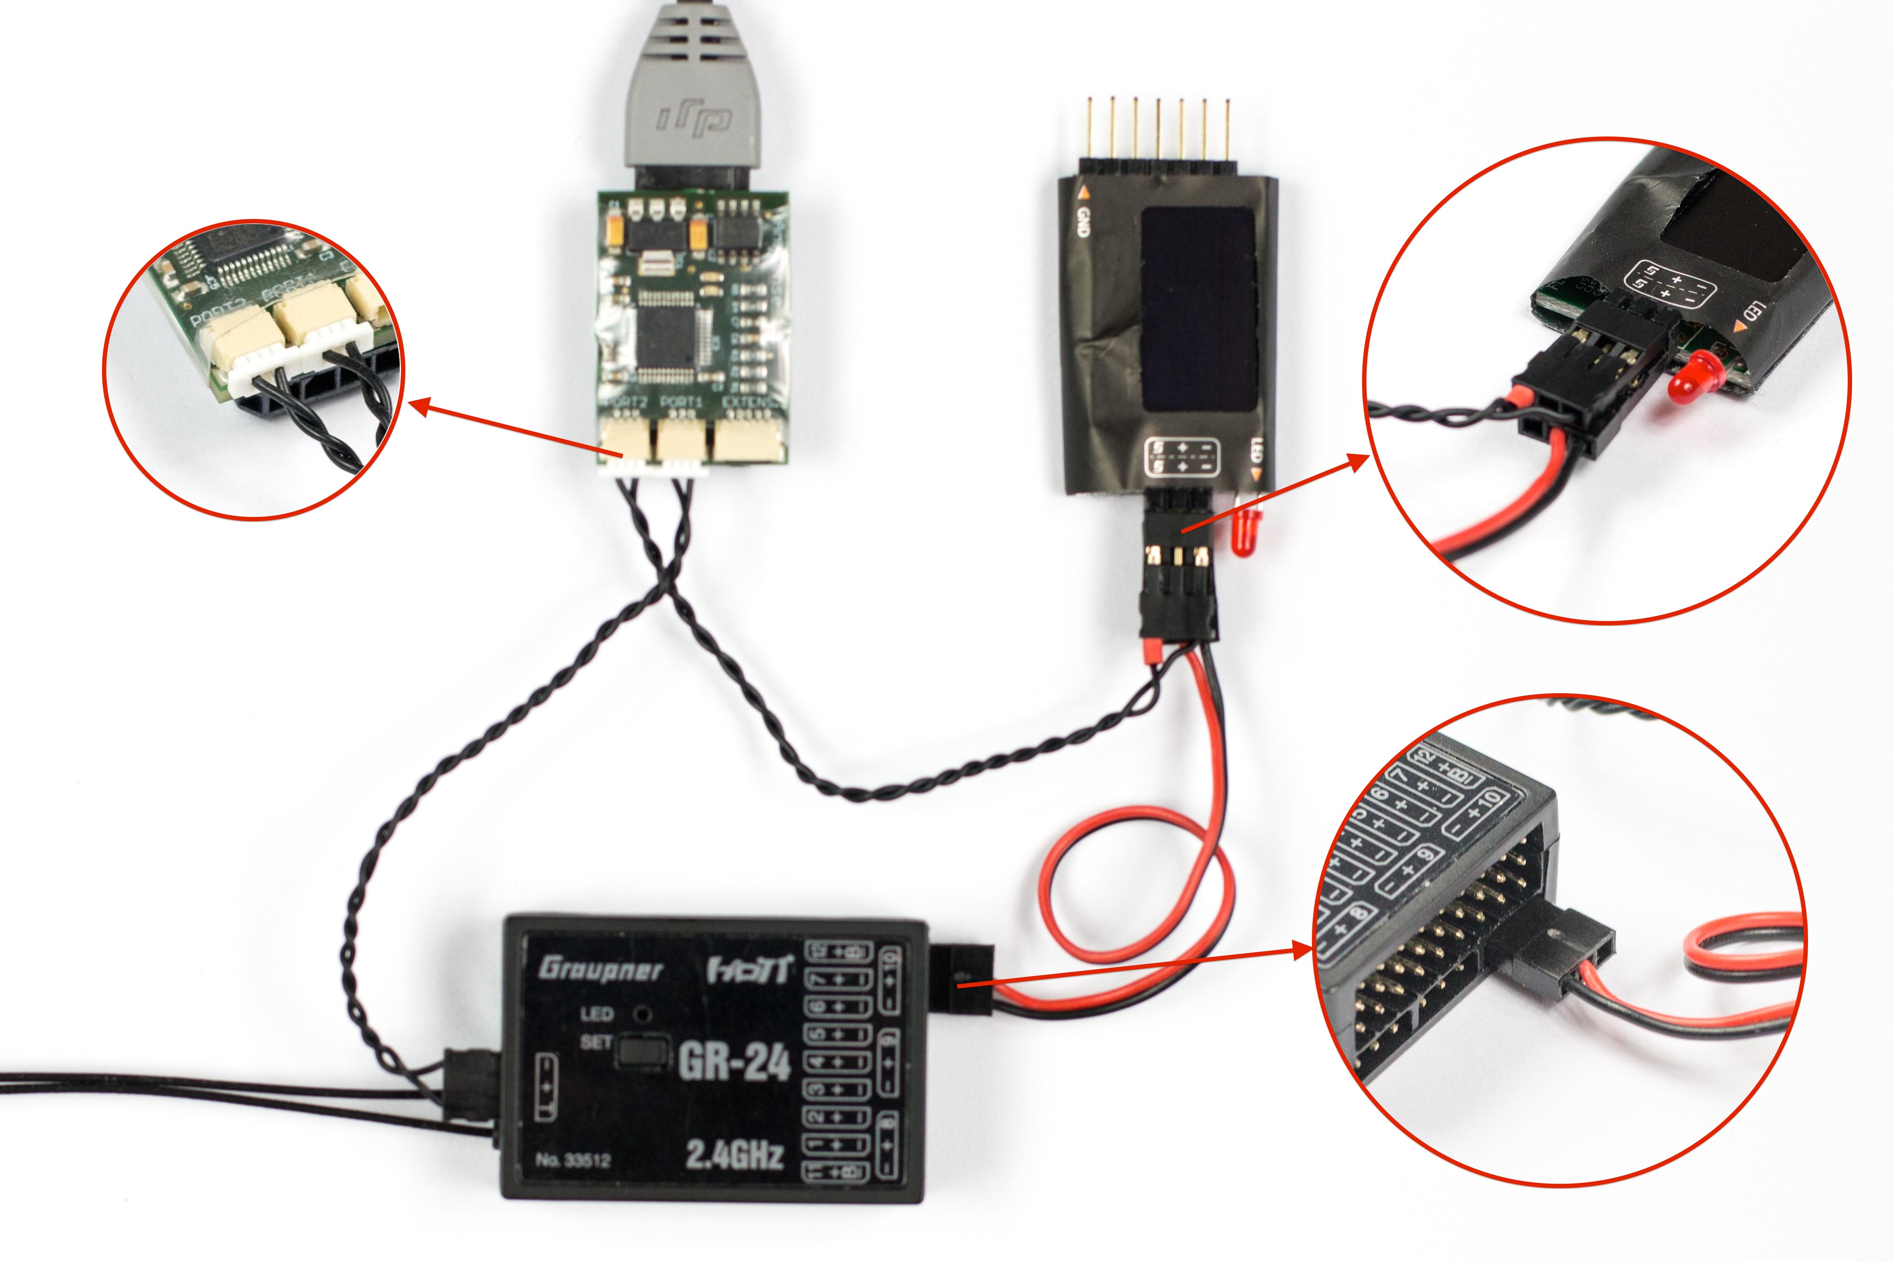The FrSky sensors are connected to port 2 of the AnySense. To do so, an optionally available telemetry cable is required. In the delivery condition of the AnySense, the connection port with the label “Port 2” is set to the FrSky. If you have carried out any changes to the configuration, it must be ensured in the Configuration Manager that FrSky S.Port on port 2 continues to be selected.

Normally, the FrSky sensors are supplied with power by the FrSky receiver. When being used with the AnySense, power must be supplied using a two-core servo cable via the Naza or the receiver.

## Add-ons with MAVLink components (MinimOSD)

With the support of the MAVLink protocol, the AnySense adapts the disparity between the standard protocol that is widespread in the multicopter segment and the DJI products.

Thus DJI pilots also gain access to many add-ons and expert functions that were previously only available for other flight controllers.

MinimOSD

The MinimOSD is a very flexible OSD, which is available for many open-source firmware. The images and descriptions presented refer to MinimOSD Extra Copter Firmware and the MinimOSD 1.1 hardware.

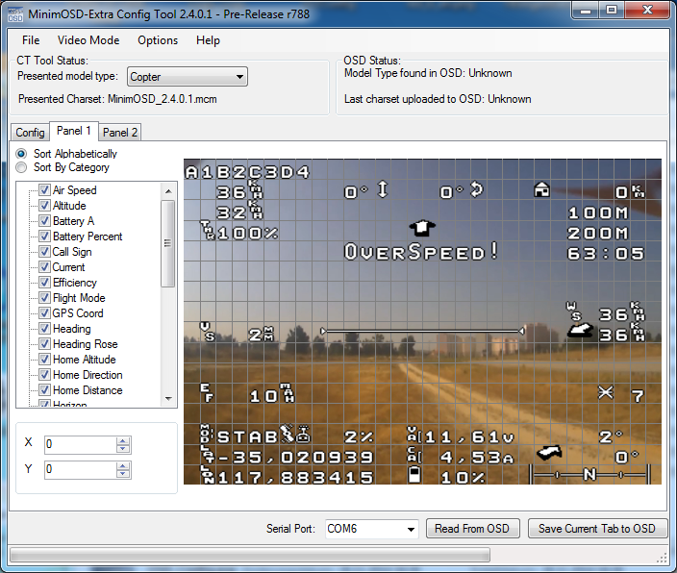

The MinimOSD makes it possible to set up two different views for the OSD, so-called panels, and to change from one panel to another during operation using a switch on the remote control.

Moreover there is an empty panel with which the OSD can be switched off.

Which telemetry information is displayed at which position in the respective panel can be defined by the MinimOSD Config Tool.

More information on the MinimOSD Extra firmware can be found on the following project page:

<https://code.google.com/p/minimosd-extra/>

An optionally available AnySense – MAVLink OSD cable is available for connecting to the AnySense to simplify the connection to the OSD.

To avoid heat problems with the OSD, it is recommended that the two soldering bridges on both sides of the OSD are closed and that the OSD is provided with a 5-volt source as depicted.

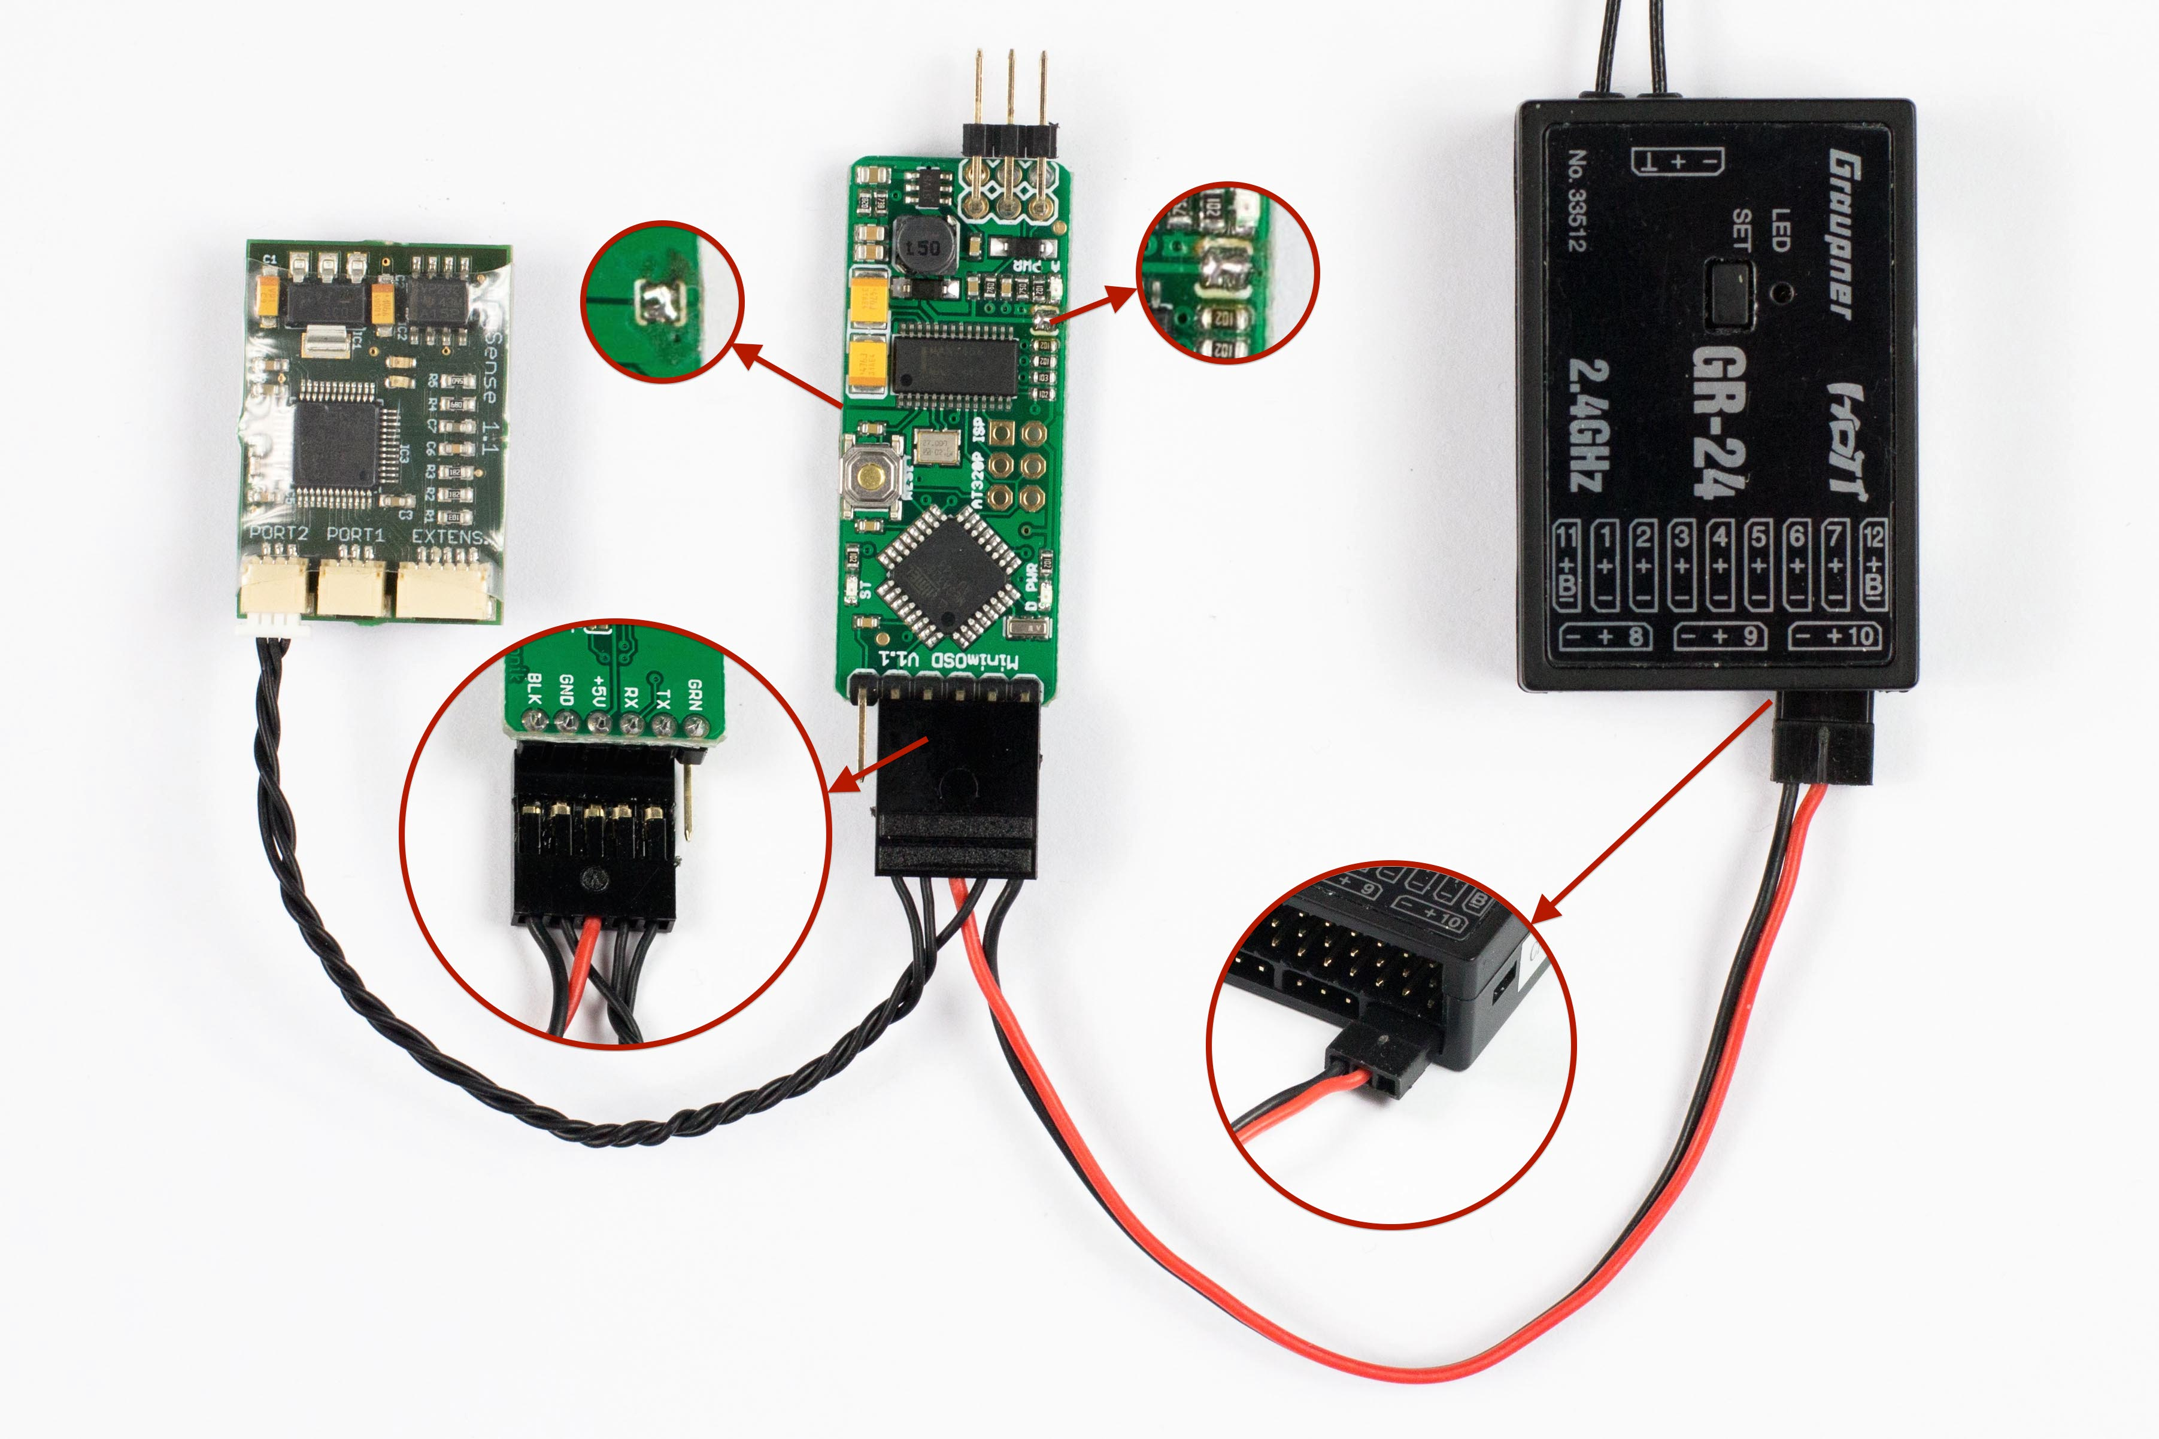In this case the receiver can act as the source of the 5-volt power supply.

To now supply the OSD with telemetry information from the flight controller, the settings for the port – port 2 in the case depicted here – must be changed in the Configuration Manager to MAVLink.

3DR radio telemetry

The 3DR radio telemetry system is likewise based on the MAVLink protocol and therefore can also be used.

This makes it possible for you to send the telemetry information from the Naza, Phantom or Wookong to the base station in real time via a separate wireless channel and then to display it, for example with the [DroidPlanner](https://play.google.com/store/apps/details?id=com.droidplanner), on your Android mobile device.

# Initial operation

Initial operation of the AnySense takes place in three steps. First, the AnySense must be connected to the DJI flight controller you are using. The next step is to select the telemetry system to be used. Finally, connection to the telemetry-capable receiver is carried out.

All three steps are described in the following chapters. The steps build on one another and it is therefore important to carry out all steps one after the other and only to carry out the next step after the previous step has been successfully concluded.

## Connection with the DJI

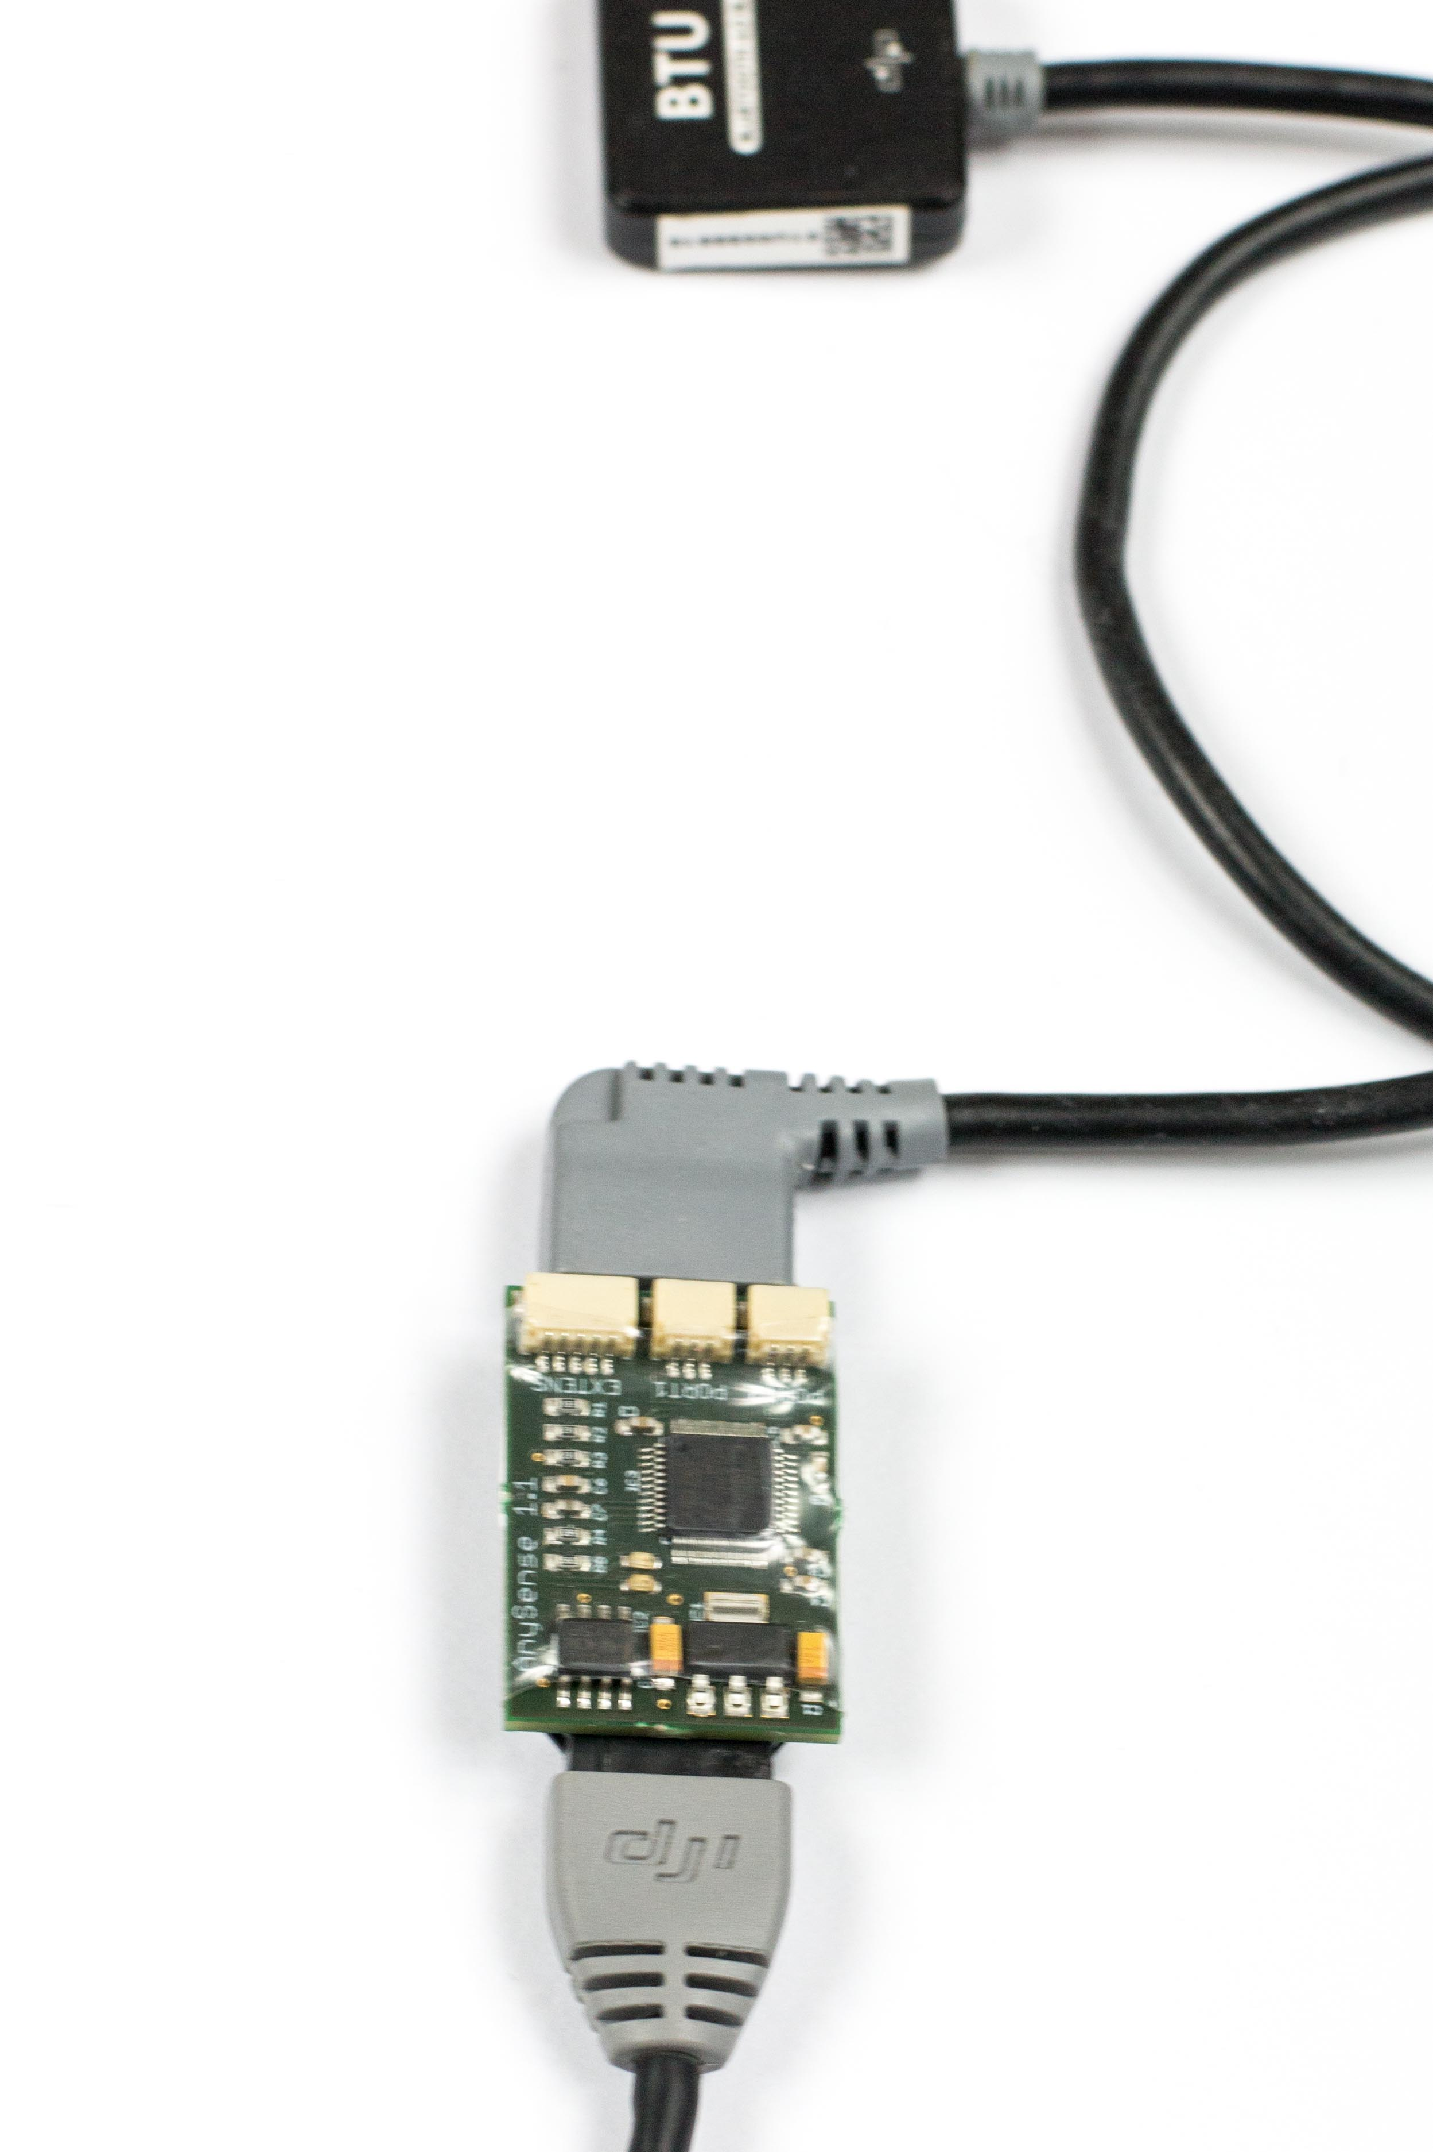Connect the AnySense telemetry module to any free CAN bus port on the DJI flight controller with a CAN bus cable. If the CAN bus port is already occupied by another component such as the Zenmuse Gimbal or the iOSD mini, the AnySense can be used as a CAN bus hub.

To do so, the other CAN bus components can be connected to the AnySense and the AnySense can then be connected to the CAN bus port that is now free.

You can check that the AnySense and the flight controller have been correctly connected by switching on the multicopter after connection has been made to the CAN bus. The green flashing LED of the AnySense signalises that the connection has been successful and communication has been established with the flight controller.

## Naza M V1/V2

For the Naza M V1/V2, the Naza PMU V2 is used to connect to the AnySense. For the V1 version of the Naza, the PMU V2 is required.

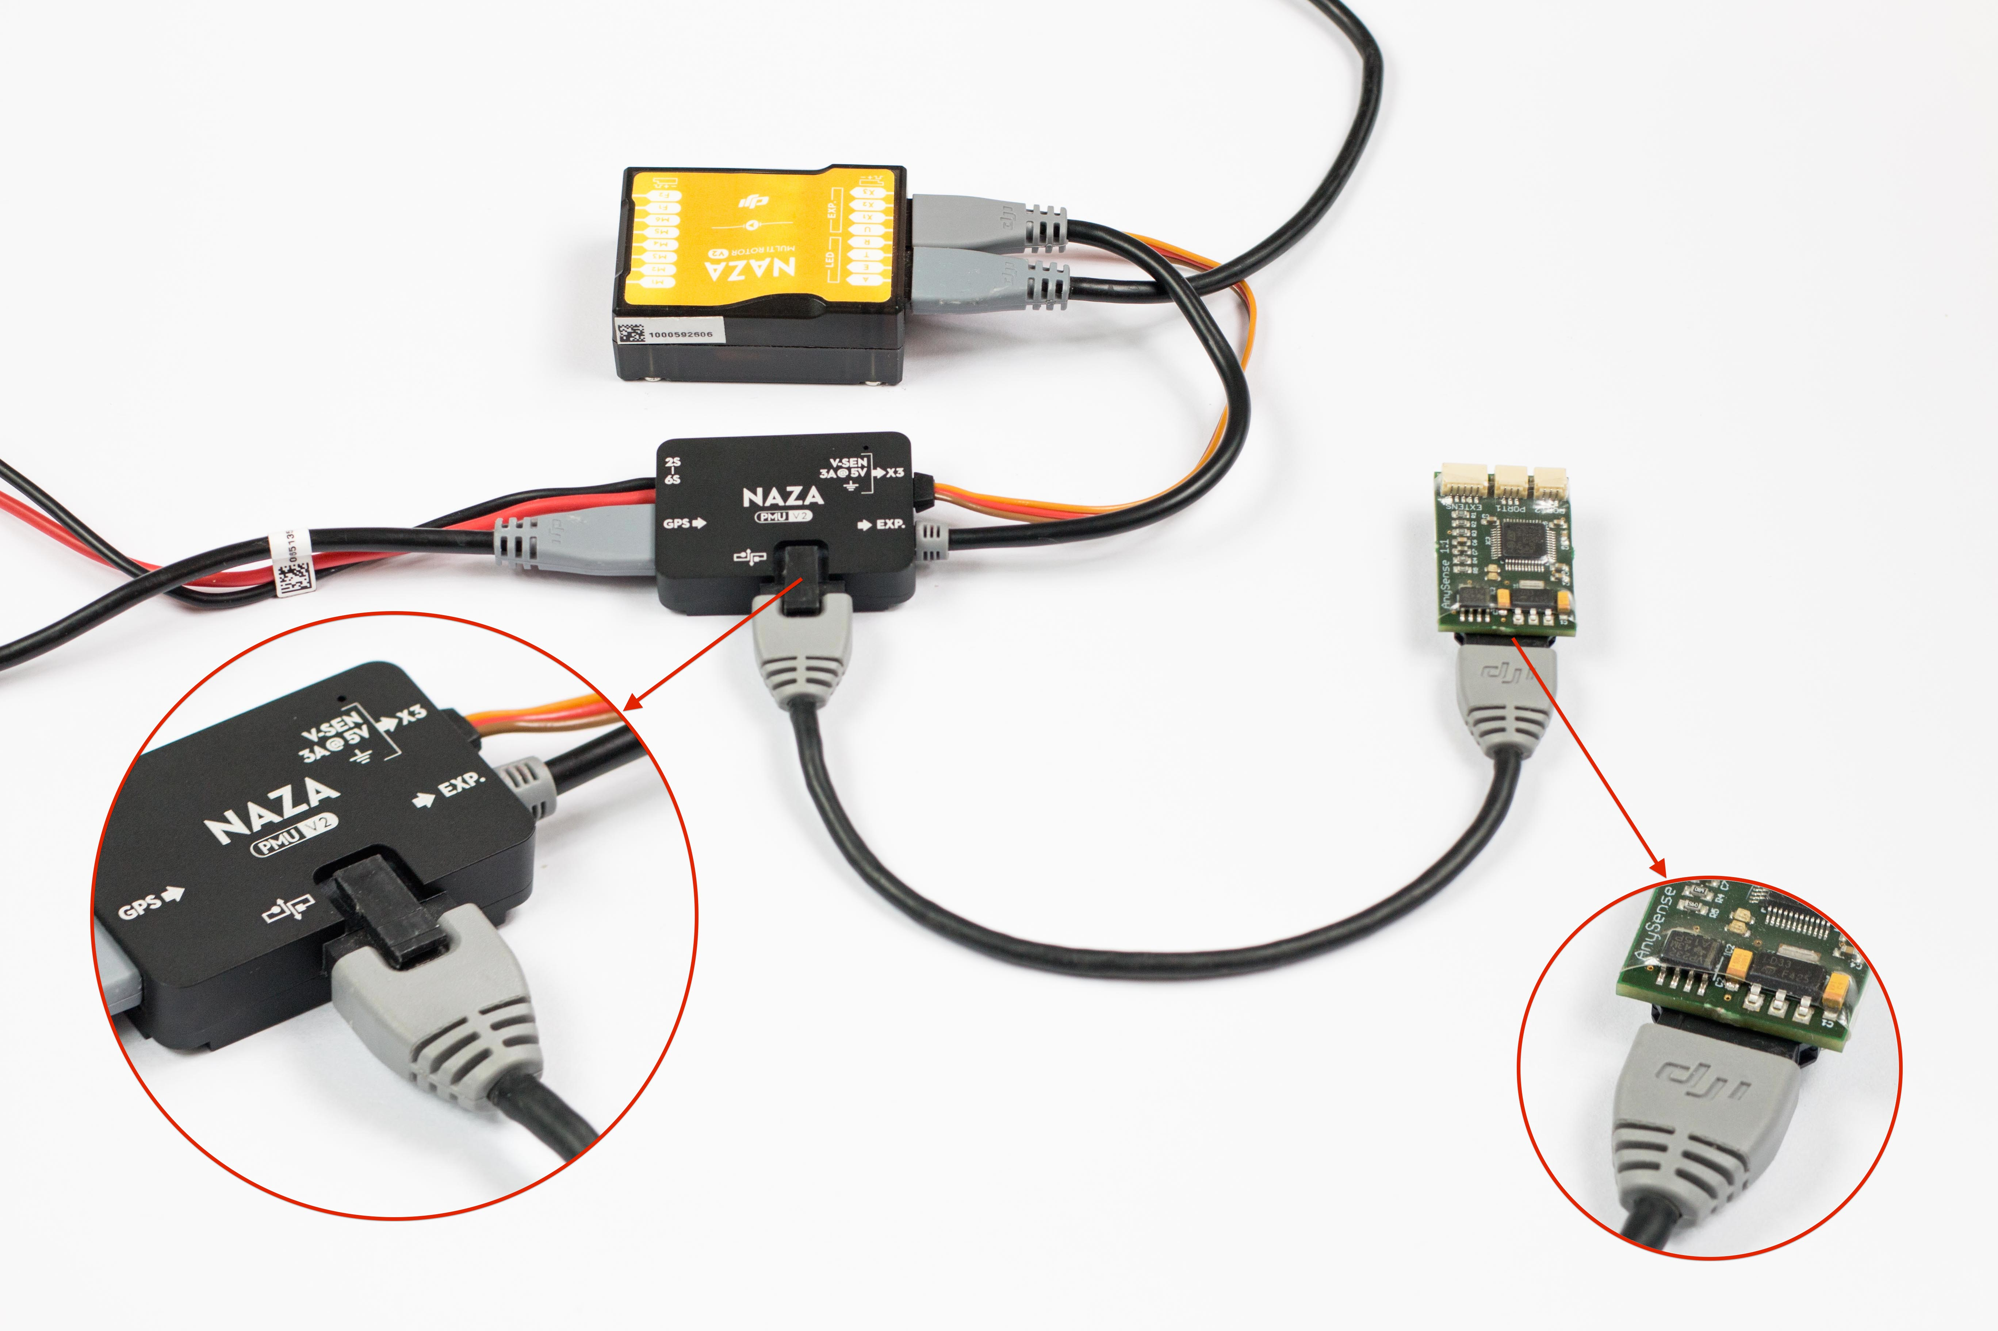

## Wookong M

In combination with the Wookong M, the AnySense can be connected either to the Wookong PMU or to the GPS.

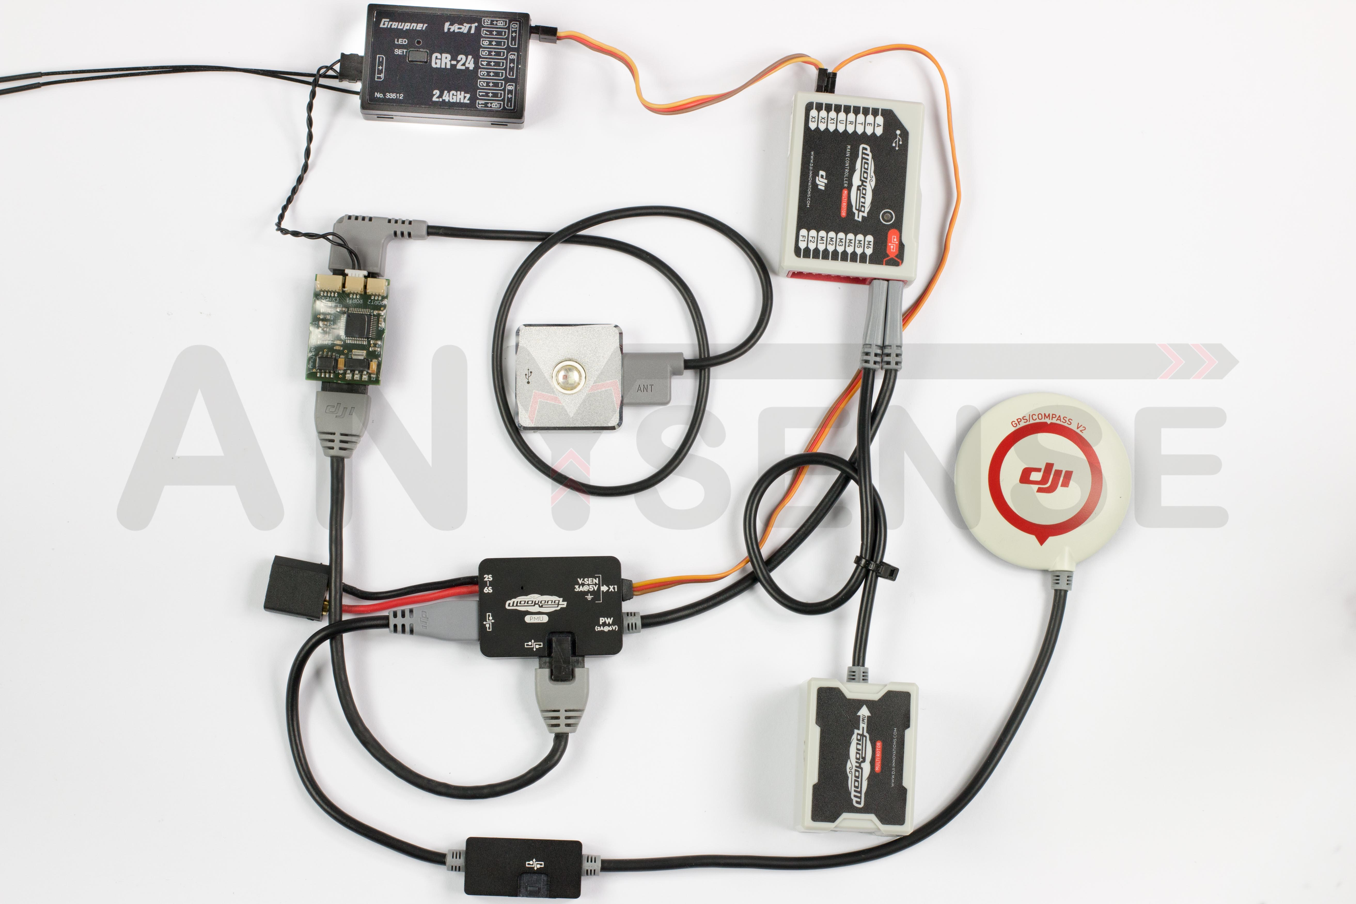

## Phantom 1

The standard version of the Phantom 1 does not have a CAN bus port and therefore it is not possible to use any accessories here such as the Zenmuse Gimbal, iOSD Mini or also the AnySense.

However the CAN bus port can be retrofitted without any problem. Detailed video instructions by DJI can be found at the following link: <https://www.youtube.com/watch?v=3I9es5y7Mrw>

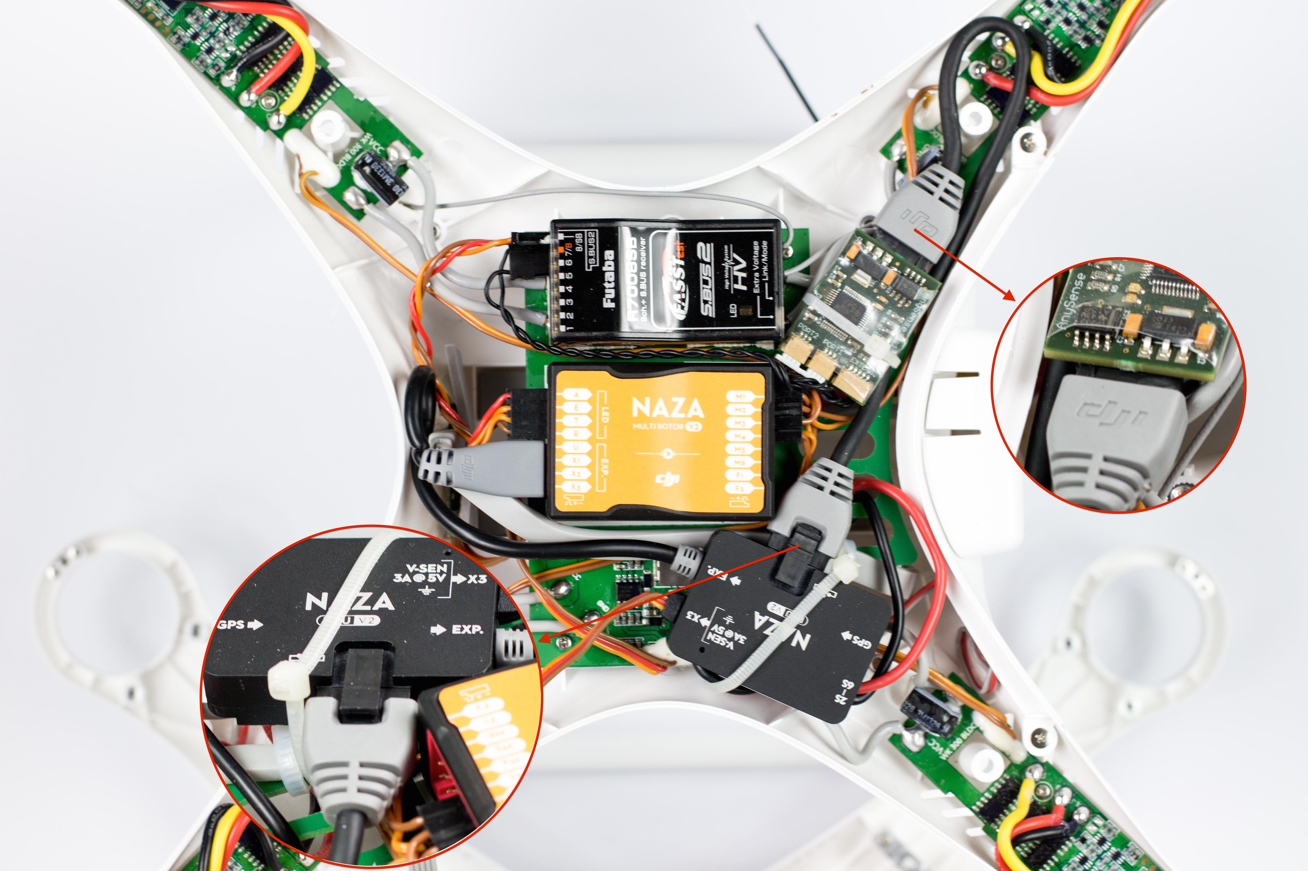

## Phantom 2

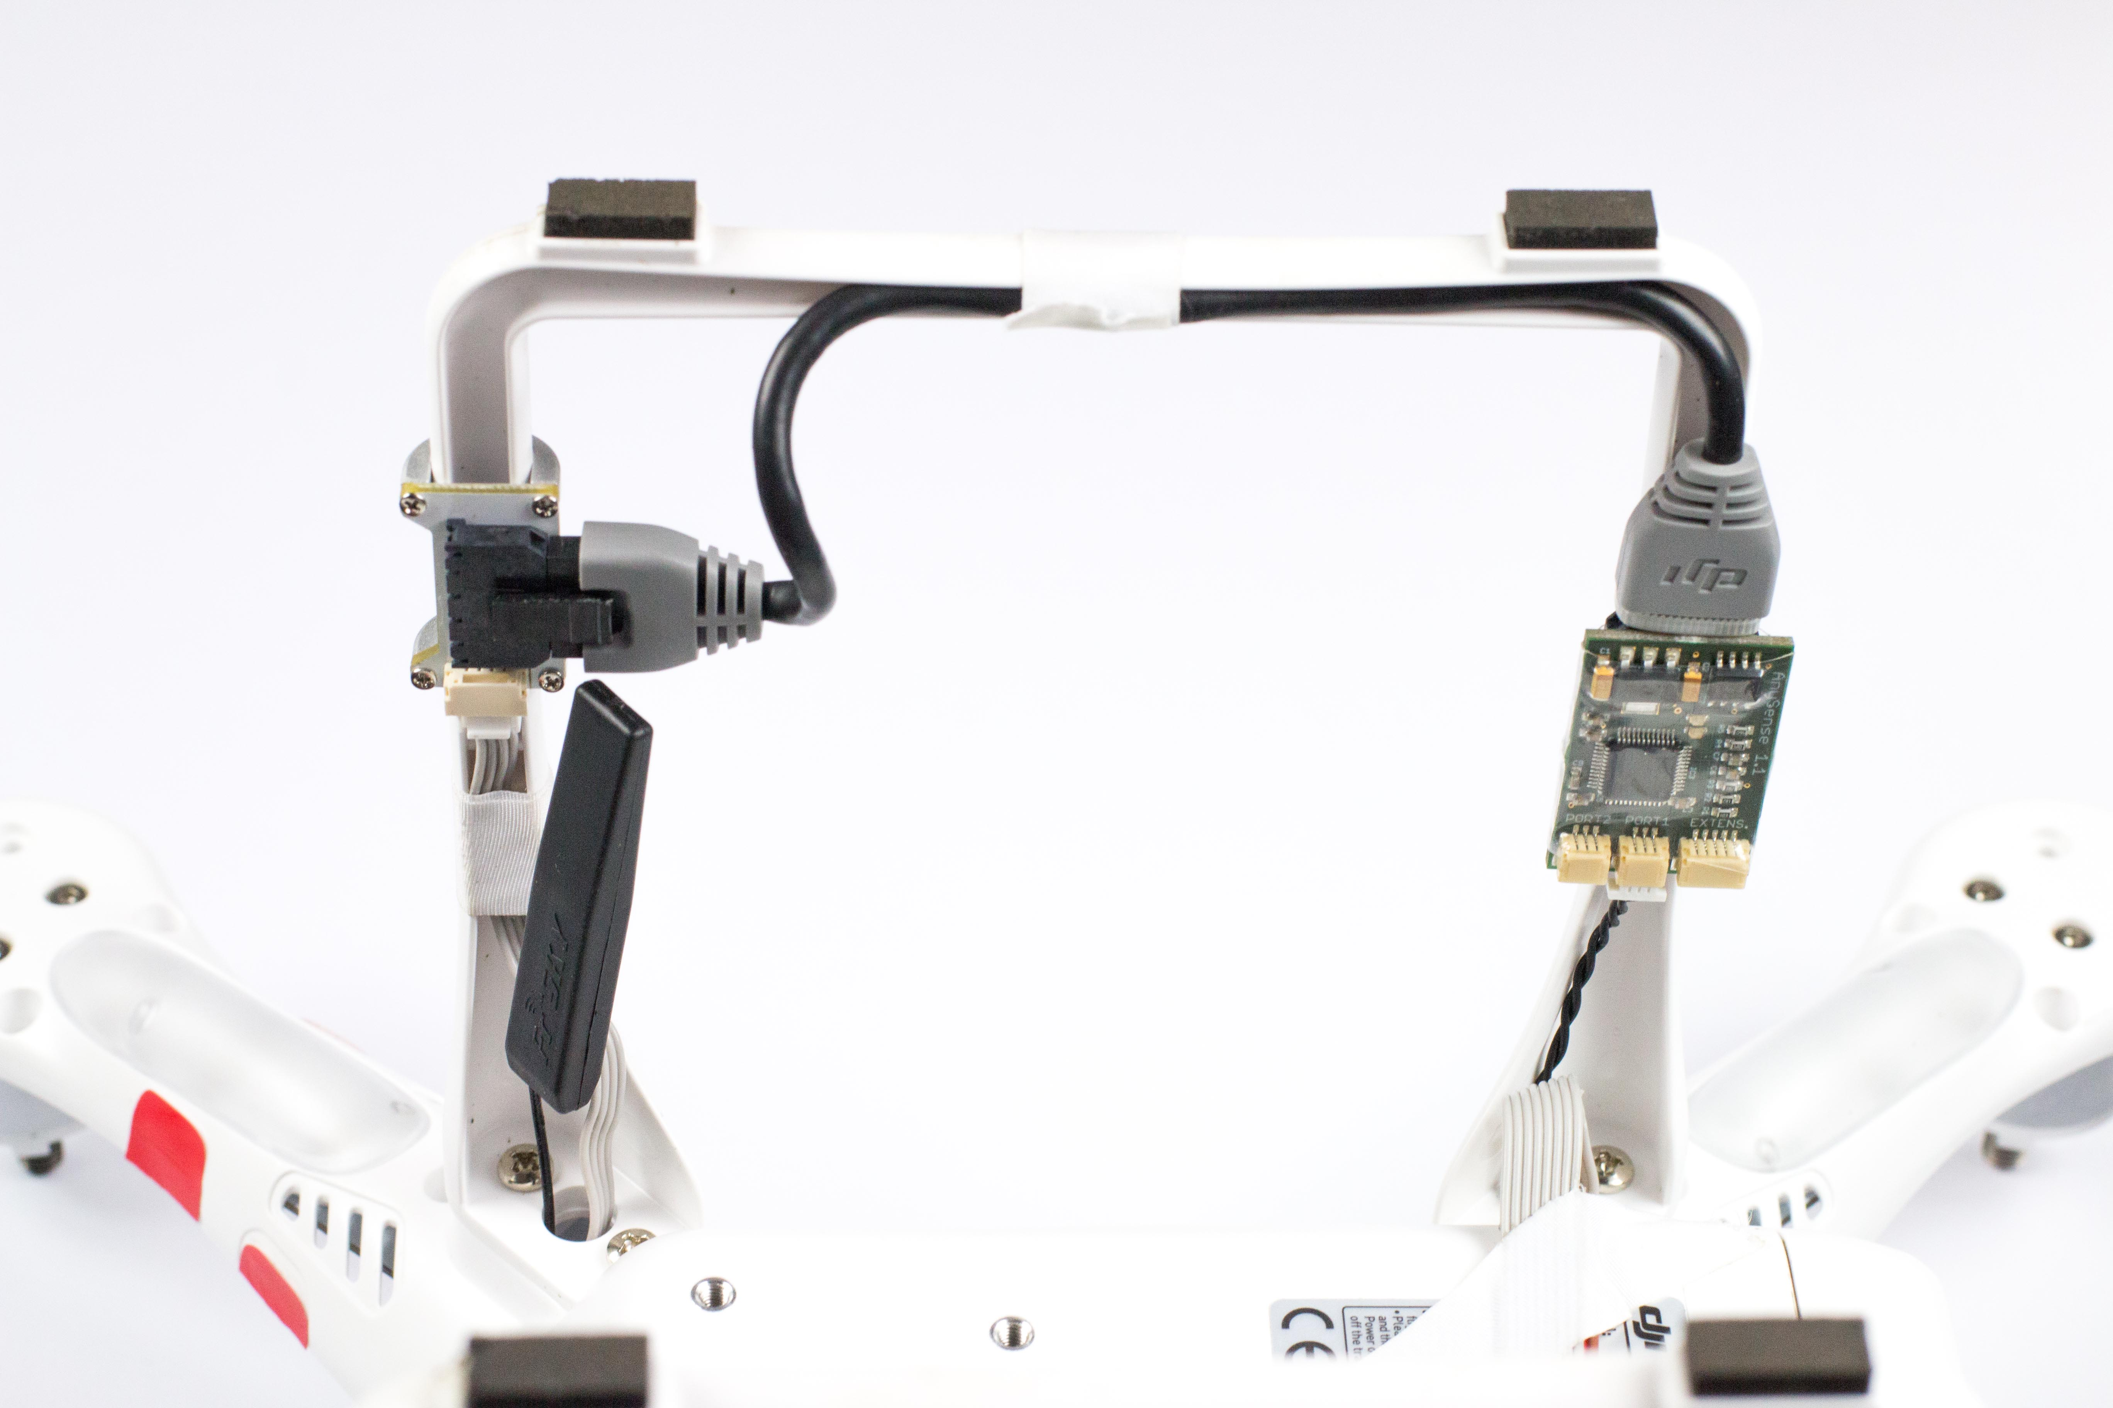The Phantom 2 CAN bus port is located on the landing gear. It is therefore recommended to also mount the AnySense on the landing gear.

The CAN bus cable can be laid along the landing gear as depicted.

To ensure error-free operation, please take care that the cable is not installed under tension or compressed.

Feed the telemetry cable to the receiver through the corresponding opening on the underside of the Phantom.

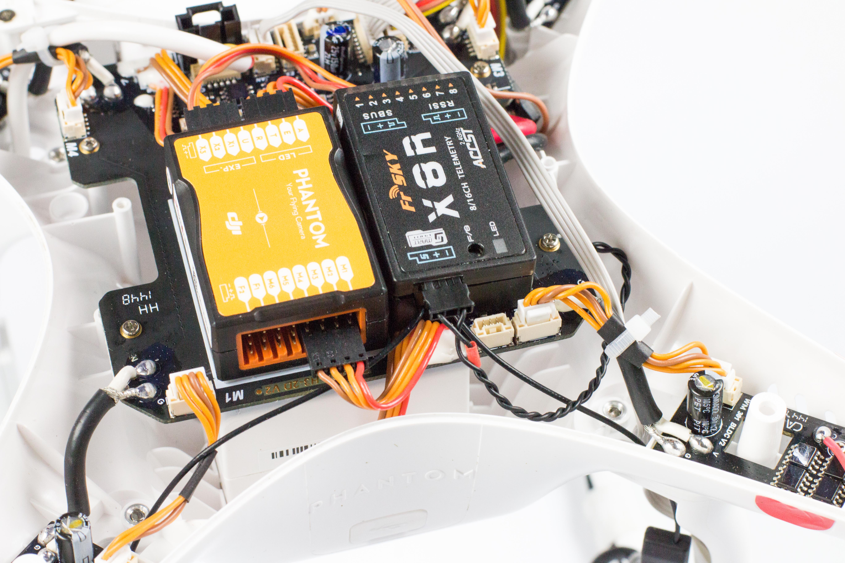

If the telemetry cable is too short to optimally lay and position the AnySense, it can be extended by a servo extension cable without any problem.

## Select telemetry system

The AnySense supports several remote control systems. To ensure that the telemetry can be transmitted to the remote control that is being used, the AnySense needs to be informed which telemetry system is going to be used. This can be carried out through the remote control or the Configuration Manager.

In both cases however, the AnySense must first be connected to the CAN bus port as described in Chapter 1 – Connection with the DJI.

In the condition as supplied to the customer the AnySense is pre-set for HoTT telemetry. In this case, therefore, you may skip the selection of the telemetry.

## Selection of the remote control

**1. Preparation**

Your remote control must already be connected and calibrated with the Naza/Phantom/Wookong. Make sure that the AnySense LEDs are visible and switch off your multicopter.

**2. Select the telemetry protocol**

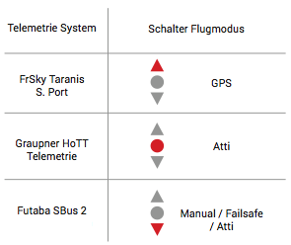

The selection of the protocol takes place via the flight mode switch. Please refer to the adjacent table for the assignation between the flight mode switch and the telemetry protocol of your remote control.

Now move the flight mode switch into the corresponding position.

**3. Confirm the telemetry protocol**

After you have selected the desired protocol, move the stick position of the remote control into one of the four depicted positions.

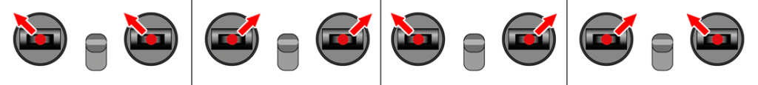

Hold this stick position and switch the multicopter on as you do so.

The red AnySense LED changes from steady illumination into rapid flashing. Continue to hold this stick position until the AnySense confirms the selected configuration with rapid flashing.

Now switch off the multicopter and the remote control and move the sticks into their regular positions and then switch on the remote control and the multicopter again.

## Selection with the Configuration Manager

The telemetry system used can be easily and conveniently selected using the Configuration Manager.

The latest software is available at <http://anysense.de/support/>.

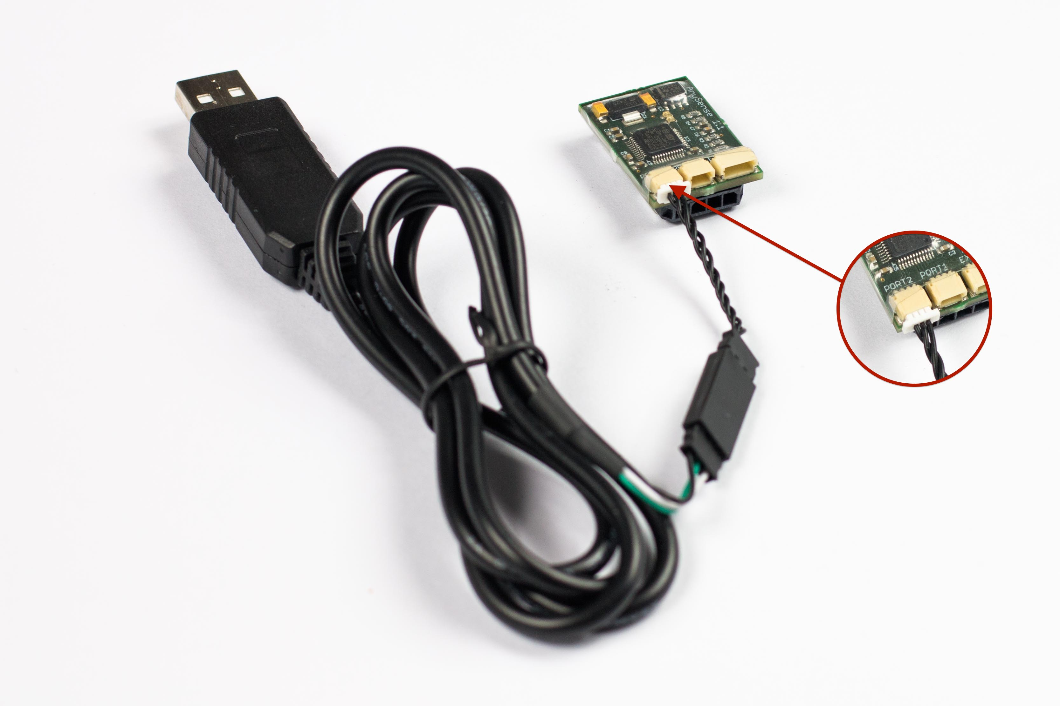

The AnySense can be connected to a PC by using the optionally available AnySense – USB programming cable.

The order plays a very large role during the connection setup and therefore it is important that it is strictly adhered to.

1. Switch off your AnySense or your multicopter.
2. Connect the USB programming cable to port 2 on the AnySense and a free USB port on your computer.
3. Start the Windows application AnySense – Configuration Manager.  
   Generally the corresponding serial port will be automatically selected in the Configuration Manager. Otherwise select the corresponding serial port.
4. Now click on the ‘Open’ button to start the connection setup.
5. Only now should you switch on the AnySense by switching on your multicopter.

Following this, all telemetry information will be displayed in real time in the status bar ‘Connected’.

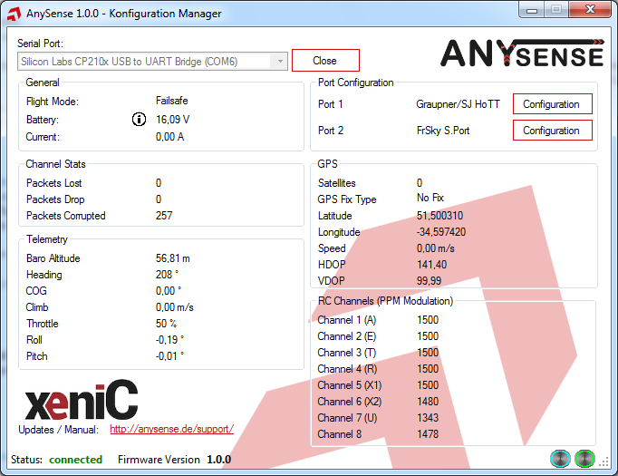

If this is not the case, please once again check the cabling and repeat the abovementioned steps.

Further sources of error are described in Chapter 4 Troubleshooting.

After the connection between the Configuration Manager and the AnySense has been established, the desired telemetry system can now be selected.

To do so open the window for the connection settings using the ‘Configuration’ button, next to the port marked Port 1.

Subsequently the telemetry system used is selected from the ‘protocol’ list.

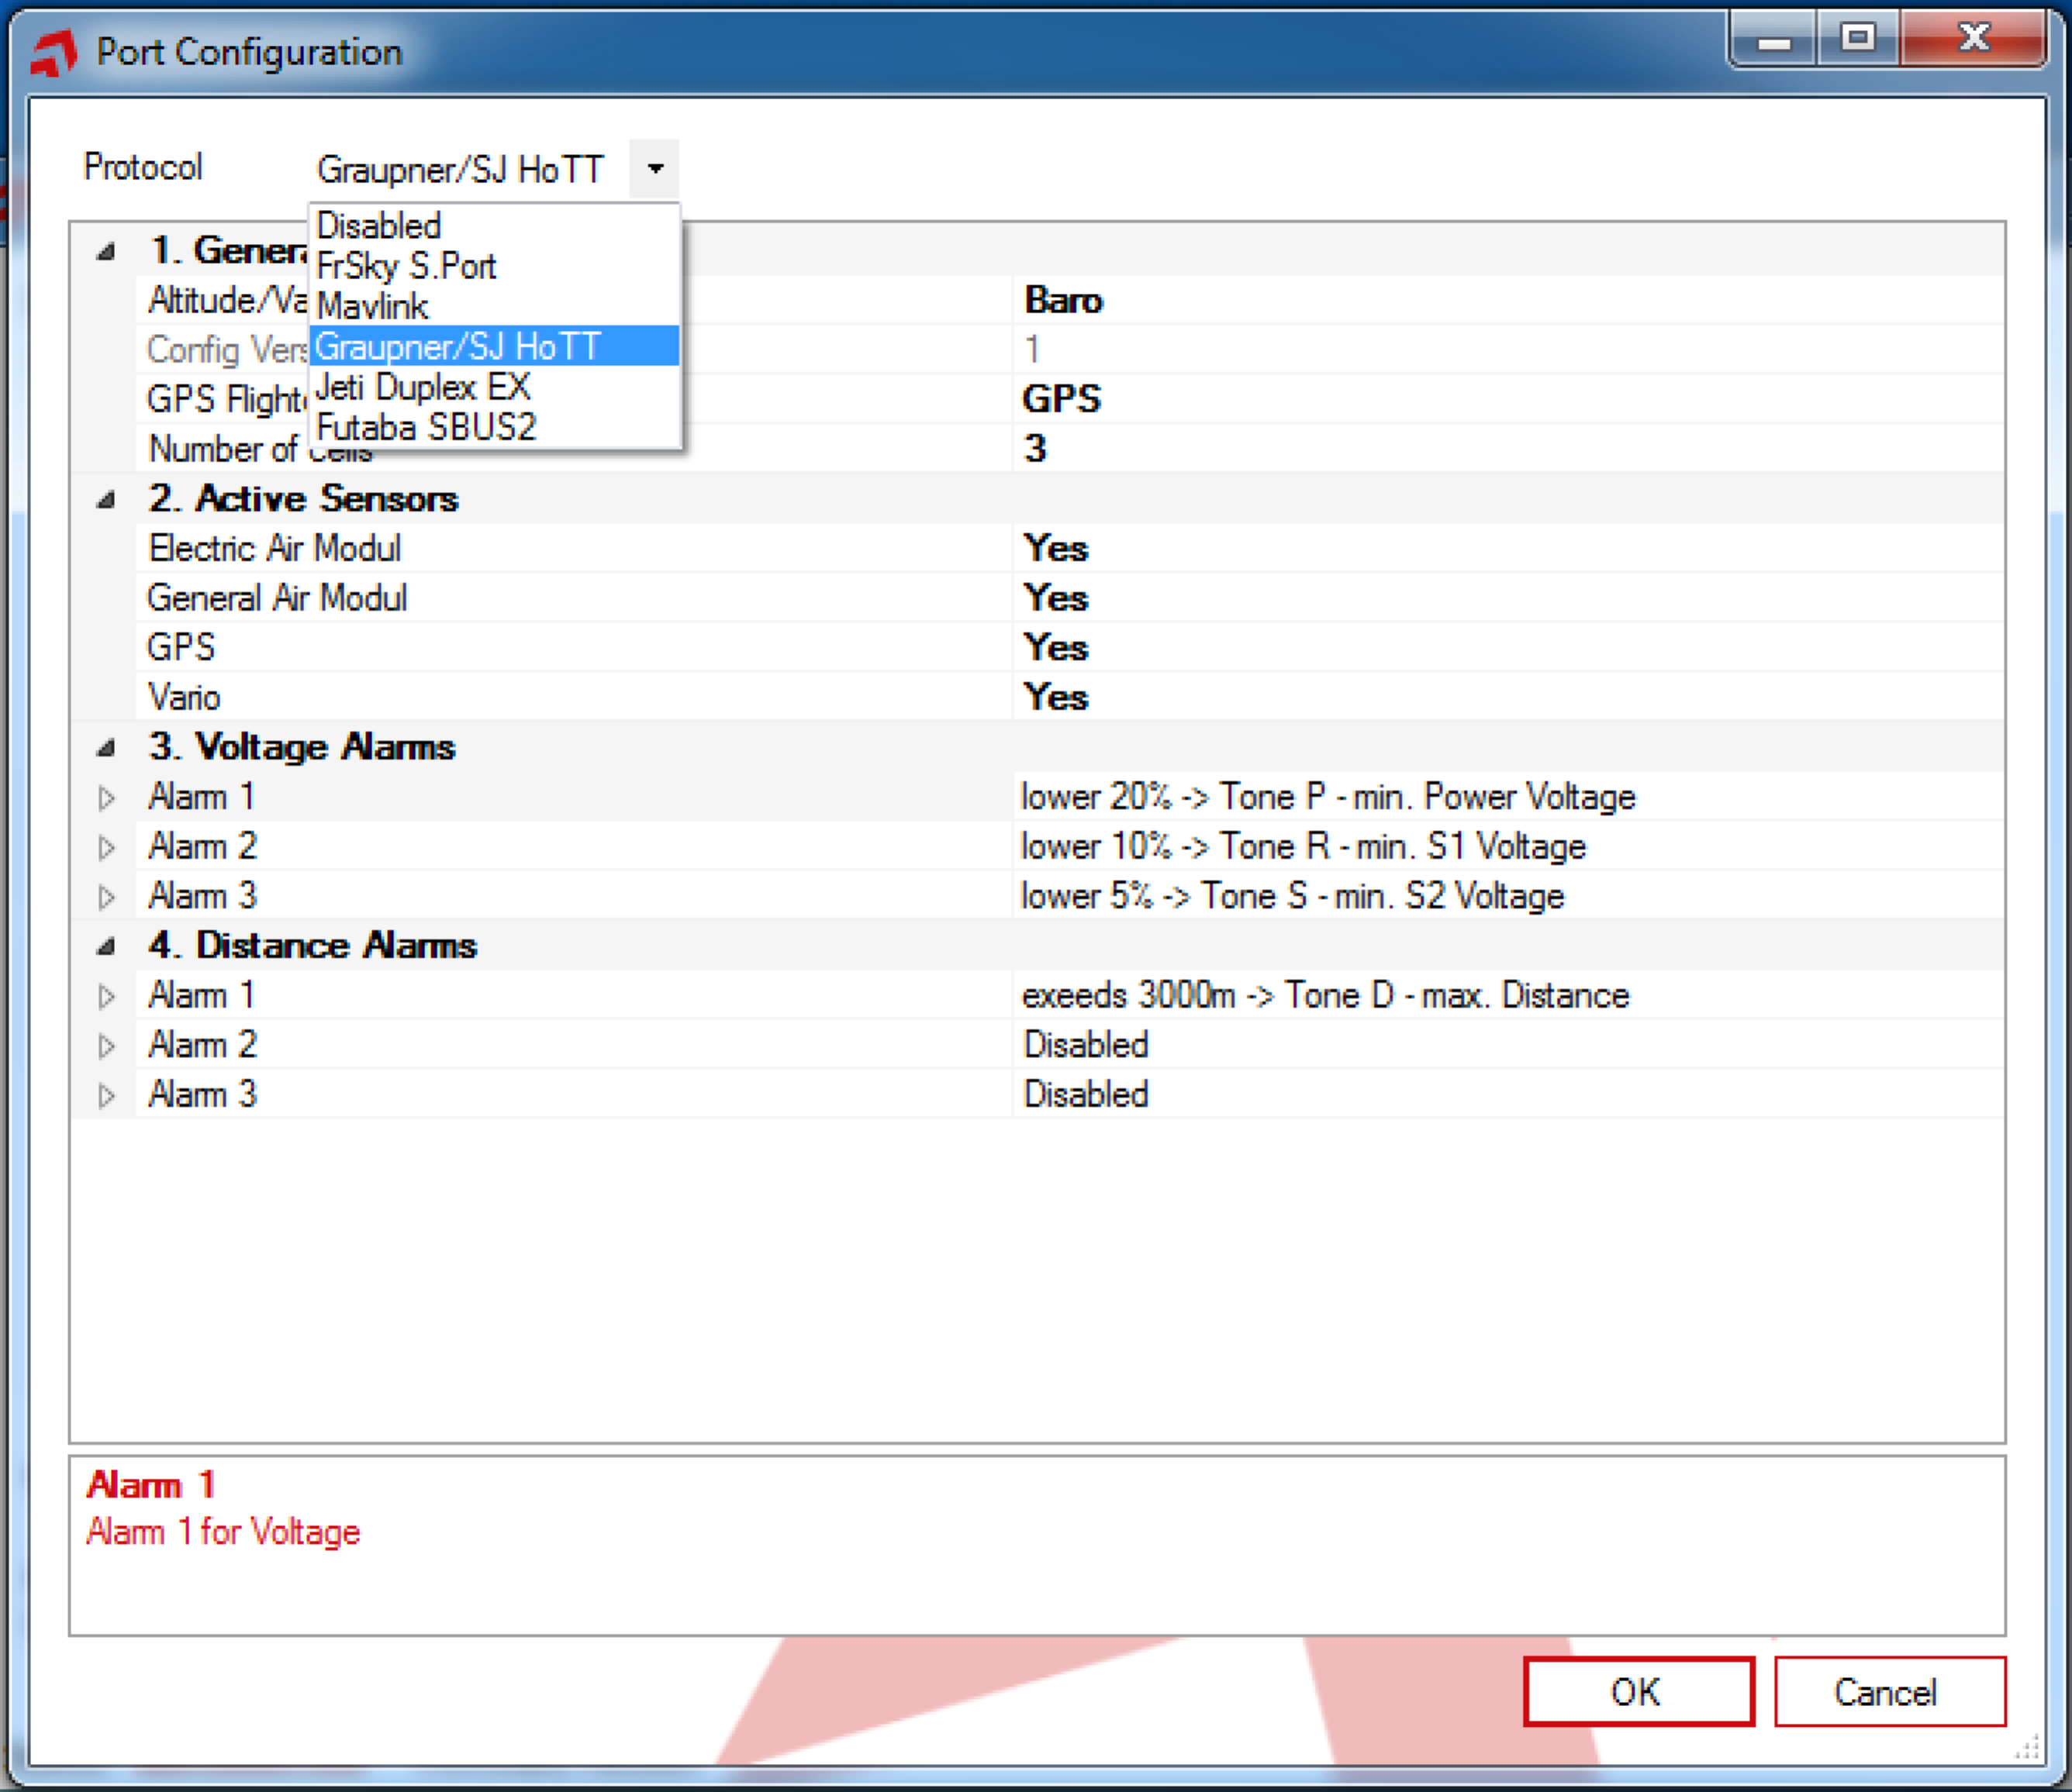

Standard settings corresponding to the telemetry system will be loaded.

No other settings are required for the initial start-up. However you can read more information about the possible settings in Chapter 3 Telemetry system.

The selection of the telemetry system is confirmed via the OK button and should now be displayed in the main window of the Configuration Manager next to the connection marked Port 1. The selection is thus completed and the connection between the AnySense and the Configuration Manager can now be disconnected by pressing the ‘Close’ button.

Further information on the Configuration Manager can be found in the Advanced configuration section.

## Connect with the telemetry system

After the AnySense has been connected to the flight controller and the telemetry system has been selected, the AnySense will now be connected to the telemetry system, which is generally your remote control receiver.

Take note of the connection diagrams and instructions in the sections relevant to your telemetry system.

## Futaba S.Bus2

The AnySense is connected to the Futaba receiver with the telemetry cable that is included in the delivery contents.

The required settings to the remote control are presented using the example of the Futaba T14SG and apply similarly to all S.BUS2-capable remote controls.

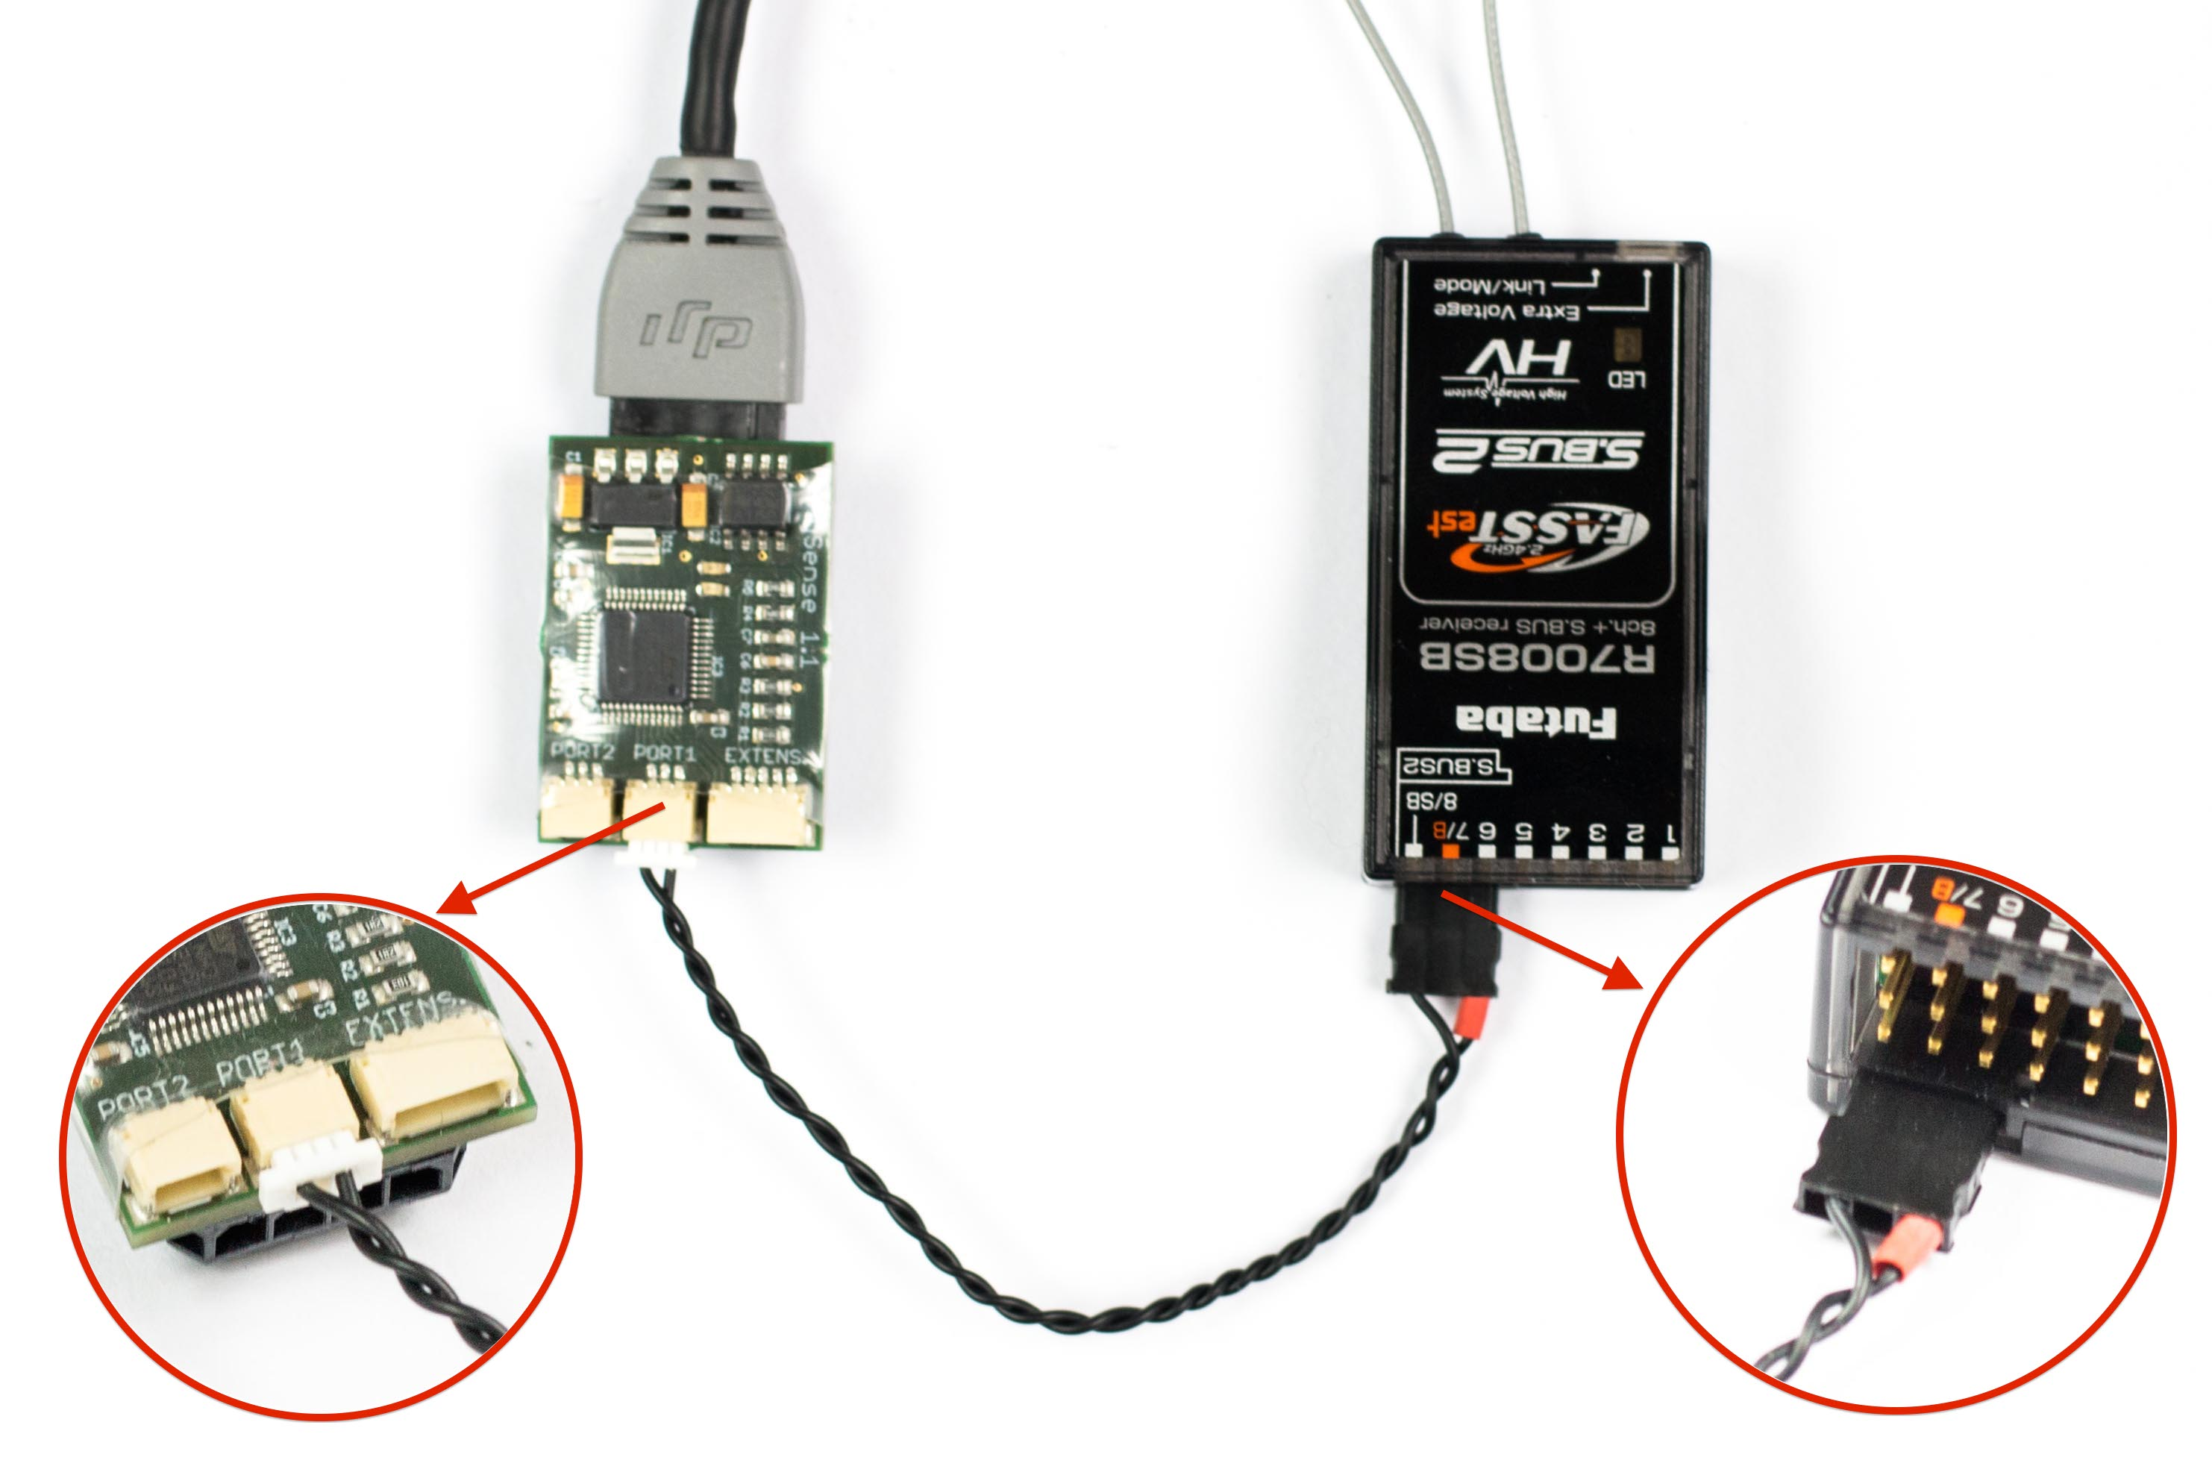The telemetry cable is connected to the port marked as S.Bus2 on your receiver as depicted.

If there is already a sensor connected to the S.Bus2 port on the receiver, the AnySense and the other sensor can be operated using a Y servo cable on the S.Bus2 port.

The connection of the AnySense to the telemetry system is thus completed.

Now switch on the remote control and use it to navigate to the base menu -> Sensors.

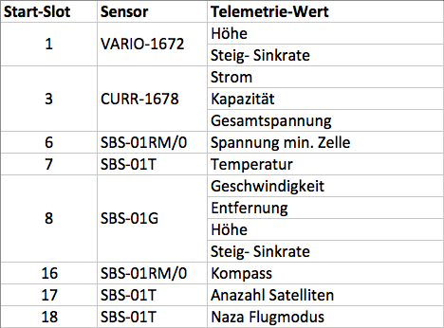Subsequently all assignments of sensors to existing slots will now be cancelled with the entry ‘RELOAD’.

The sensors will now be selected slot for slot, beginning with row number 1 as depicted.

Selection takes place by selecting the INACTIVE entry in the sensor list and selecting the corresponding sensor.

After all sensors have been selected as depicted, the telemetry information can be displayed by the base menu -> Telemetry.

For further information about telemetry, please refer to the manual for your Futaba remote control.

## Graupner/SJ HoTT

Depending on the receiver used, the AnySense will be connected to the receiver by a dedicated or optional telemetry port. Generally this port is marked with a T.

Please refer to the manual for your remote control/receiver for information on how telemetry sensors can be operated.

For parallel operation of several sensors, the sensors and the AnySense are operated with a Y servo cable on the receiver.

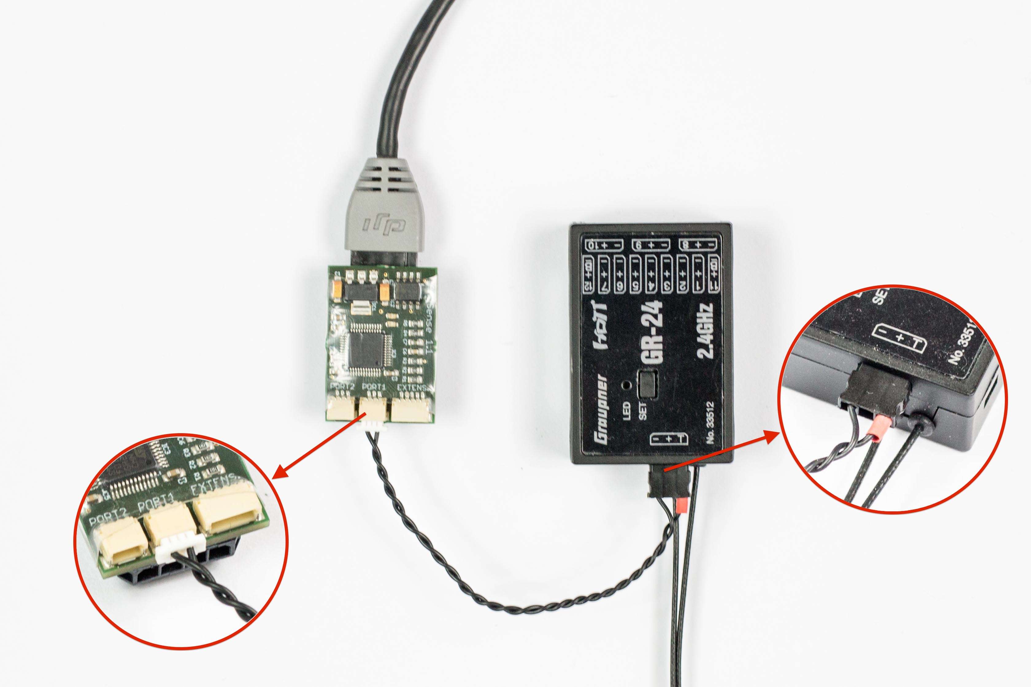The GR-24 has a dedicated telemetry port and, as depicted, is connected to the port marked with a T.

After connecting the AnySense, it is necessary to restart the remote control. All available sensors will be automatically identified and the AnySense will be ready for operation. Descriptions of the available telemetry displays and their meaning can be found in the manual for your remote control.

## Jeti Duplex EX

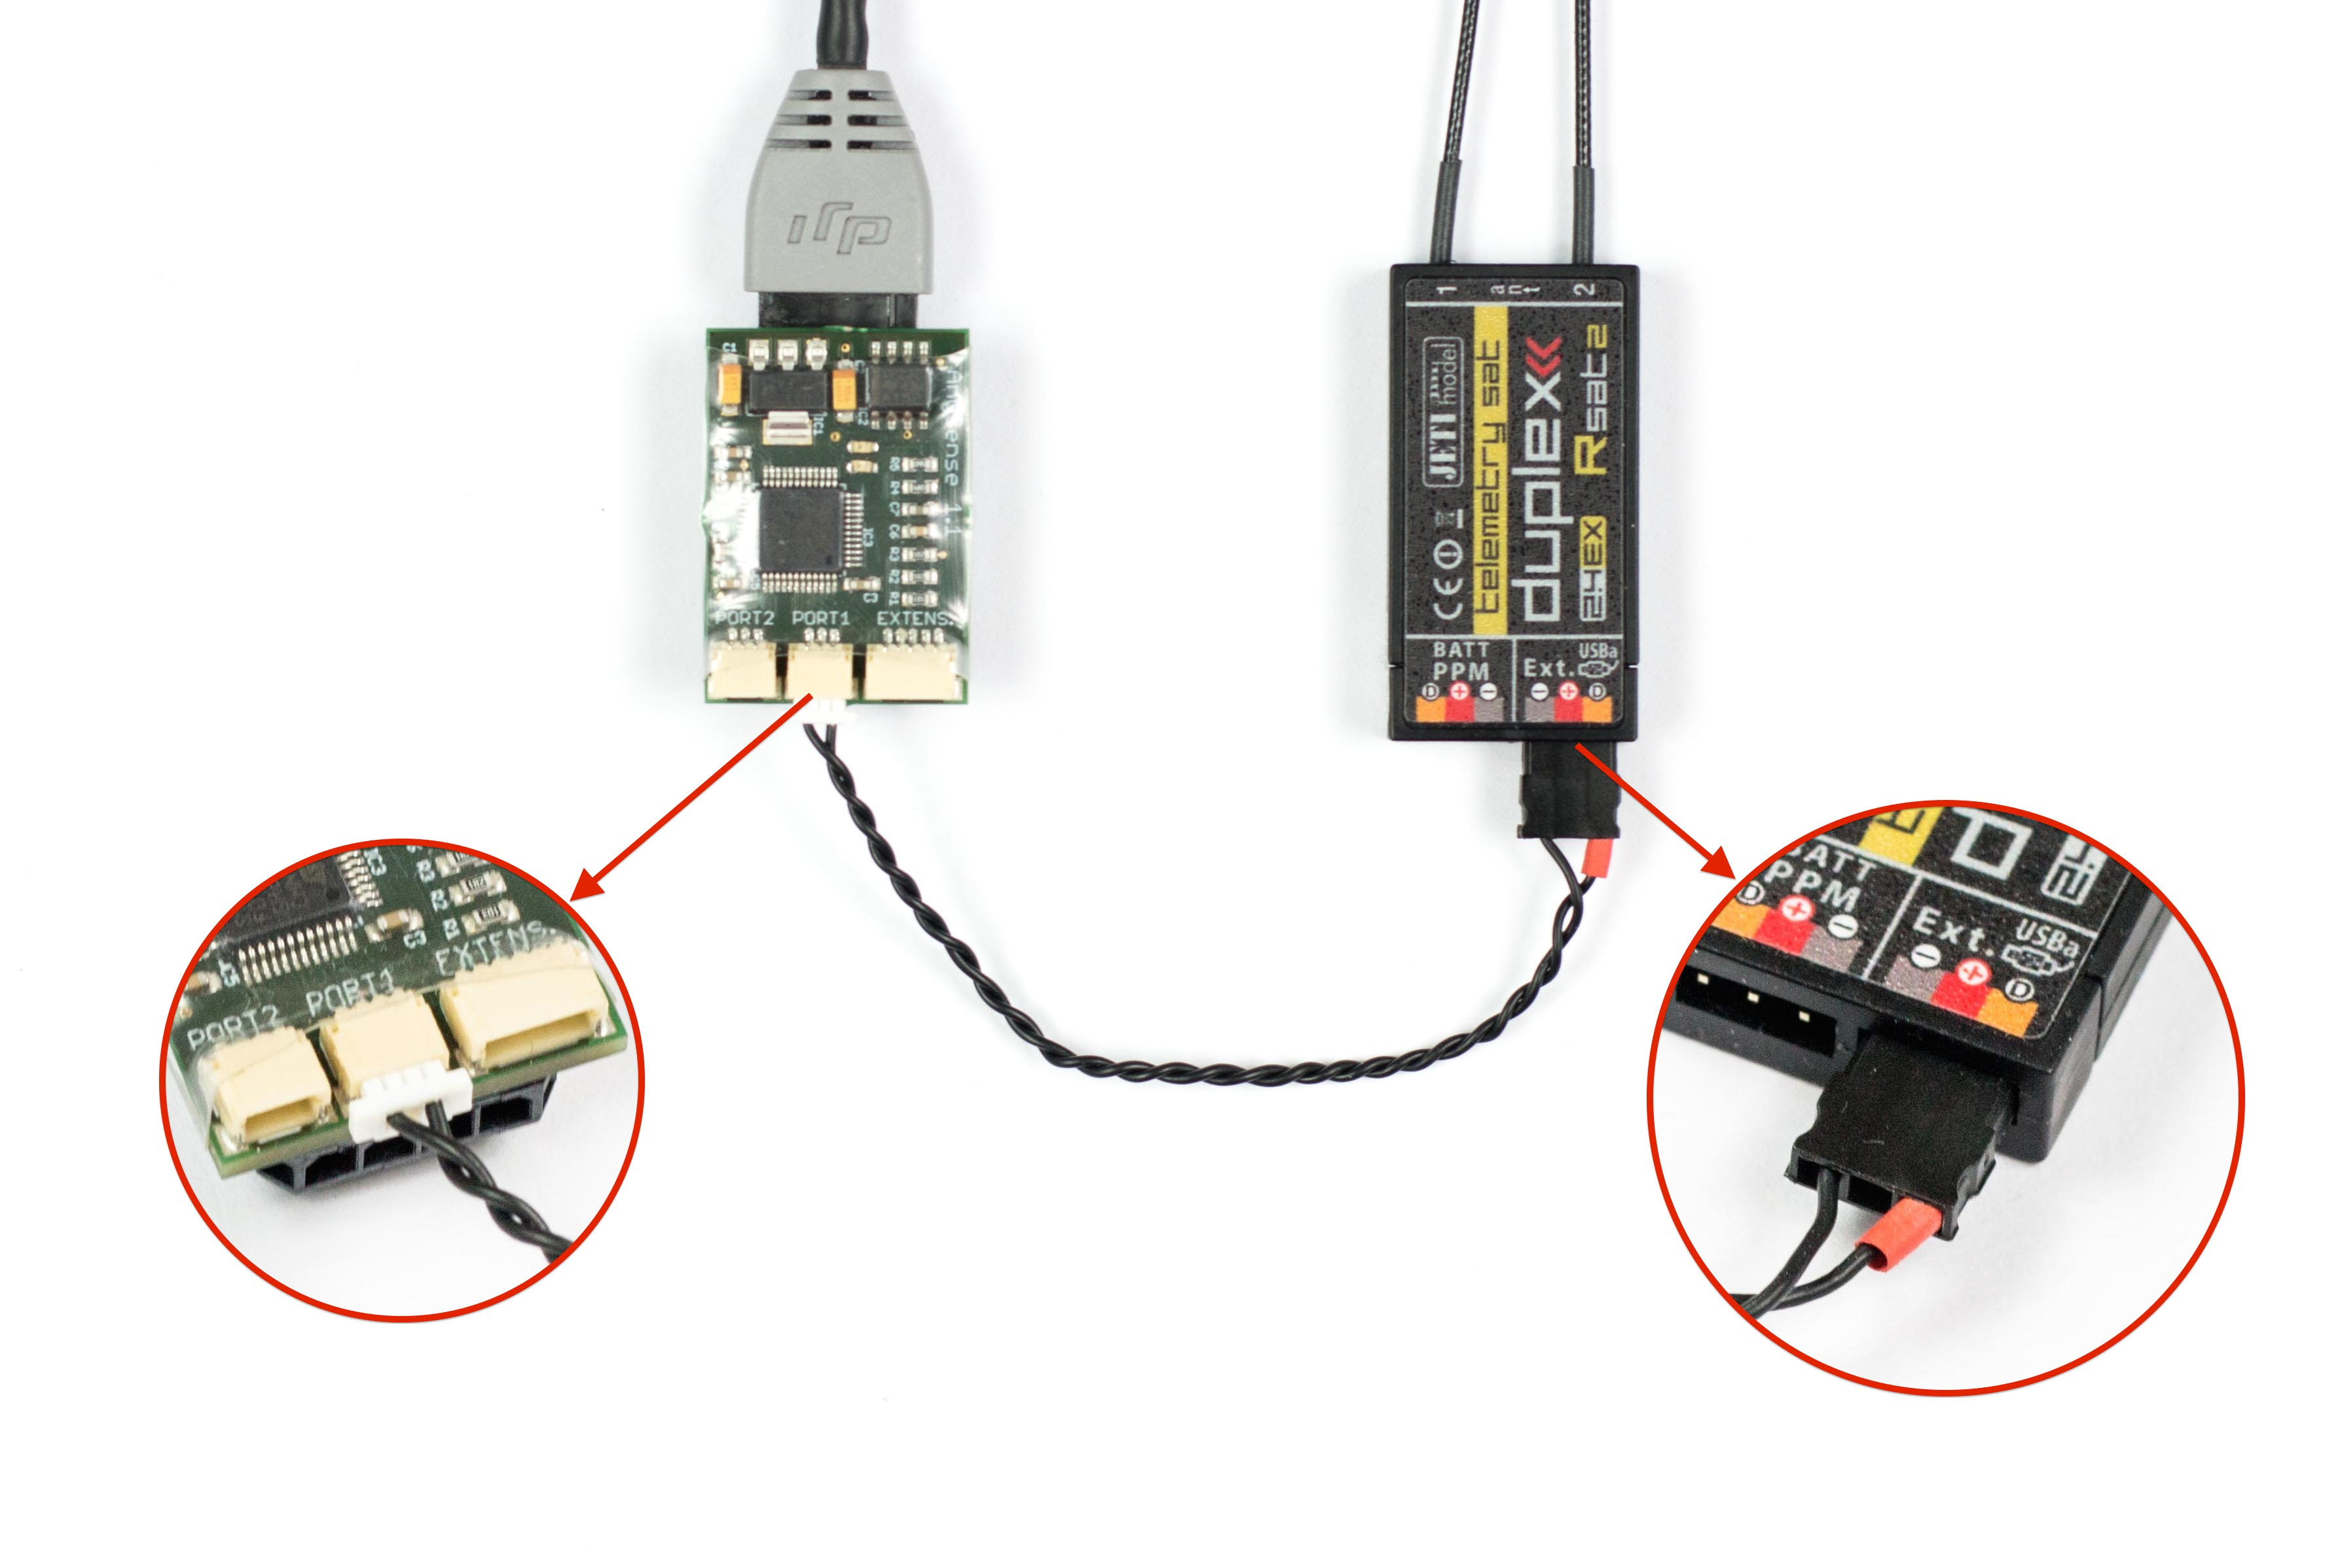The AnySense is connected with the Ext. port on the telemetry-capable receiver.

When using additional sensors, the AnySense is connected to the Jeti Expander EX.

After the connection has been established as depicted, switch on your remote control and your multicopter.

Now all available information will be displayed in the telemetry display of your remote control. Further information on the telemetry display can be found in the manual for your remote control.

## FrSky S.Port

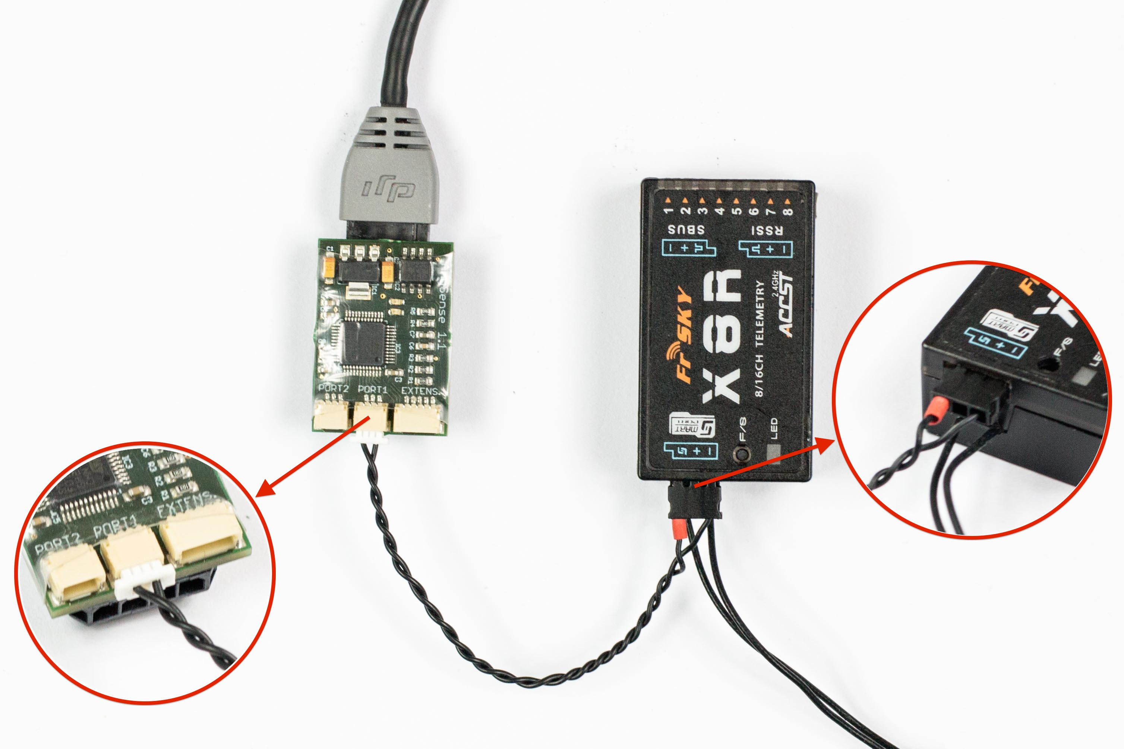The latest X generation (X 8/6/4 R) of FrSky sensors are equipped with the Smart Port. The port is generally marked with the Smart Port logo and is located on the same side as the receiver antenna. Further information on the S.Port connection on the X4R can be found in the manual for your receiver.

The AnySense is connected to the S.Port connection of the receiver as depicted.

For the parallel operation of further sensors and the AnySense, they can simply be daisy-chained together with the telemetry port on the receiver. Every sensor has a two-rowed S.Port connection for this.

After the AnySense has been connected, you now need to select the telemetry values to be displayed on your remote control.

This can be carried out directly through the remote control menu (page 12 – Telemetry) or using the OpenTX software.

Moreover individual graphical interfaces can be carried out by means of so-called LUA scripts.

For further information on the subject of LUA scripts, go to <http://www.open-tx.org/lua-instructions.html>

## Troubleshooting

**You cannot establish a connection with the Configuration Manager.**

The AnySense must be connected to the CAN bus port and the AnySense - USB programming cable must be connected to port 2. You may only switch the multicopter on after you have clicked on the ‘Open’ button.

**The AnySense – USB programming cable has not been recognised.**

Generally the corresponding driver will be automatically installed. Alternatively you can also manually download and install the driver from the following address.

<http://www.prolific.com.tw/UserFiles/files/PL2303_Prolific_DriverInstaller_v1_10_0_20140925.zip>

**You have Windows 8/8.1 and the AnySense – USB programming cable has not been recognised.**

The AnySense – USB programming cable is currently not supported by Windows 8/8.1. However there is an unofficial driver that allows the installation to work with Windows 8/8.1. For initial start-up, first load and install the following driver:

[Prolific PL2303 USB serial driver (3.3.2.102)](http://anysense.de/wp-content/uploads/2015/02/PL2303_USBSerial_Win78_3264.zip)

After the driver has been installed, please follow these instructions step by step:

1. Open the Device Manager
2. Under ports (COM & LPT), click on the corresponding port with the right mouse button and click on ‘Update driver software’.
3. In the new window, click on ‘Search the computer for driver software’.
4. In the next step, click on ‘Select from a list of device drivers on the computer’.
5. Remove the tick at ‘Display compatible hardware’.
6. Select Prolific as manufacturer and install the ‘Prolific USB-to-Serial Comm Port Version:3.3.2.102’ model.

It should now be possible to also use the AnySense – USB programming cable with Windows 8/8.1.

**Unusual information is displayed in the telemetry.**

Adequate GPS reception is required to ensure that some data can be correctly displayed. Therefore, for testing, please go to a location where the GPS signal has a minimum of three satellites.

**No data is displayed in the telemetry.**

First check the progress bar of the red LED. If this does not flash, there is no connection between the AnySense and the telemetry system used. In this case, repeat the steps described in Chapter 2 ‘Select telemetry system’ and Chapter 3 ‘Connect with the telemetry system’.

# Advanced configuration

In its delivery condition, the AnySense is optimally configured for the remote control used. Furthermore, it is possible to further adjust the AnySense to the individual surroundings.

Adjustment is carried out via the Configuration Manager. Similarly, firmware updates can be carried out through the Configuration Manager. In the next section, all setting options of the respective telemetry system will be explained in more detail.

## Configuration Manager

The Configuration Manager is a graphical interface that makes it easy to configure the AnySense. To establish a connection with the Configuration Manager, the AnySense must first be connected to the CAN bus port of the flight controller.

The latest software is available at <http://anysense.de/support/>.

The AnySense can be connected to a PC by using the optionally available AnySense – USB programming cable.

The order plays a very large role during the connection setup and therefore it is important that it is strictly adhered to.

1. Switch off your AnySense or your multicopter.
2. Connect the USB programming cable to port 2 on the AnySense and a free USB port on your computer.
3. Start the Windows application AnySense – Configuration Manager.  
   Generally the corresponding serial port will be automatically selected in the Configuration Manager. Otherwise select the corresponding serial port.
4. Now click on the ‘Open’ button to start the connection setup.
5. Only now should you switch on the AnySense by switching on your multicopter.

Following this, all telemetry information will be displayed in real time in the status bar ‘Connected’.

## Firmware update

AnySense firmware is always available with the current Configuration Manager version.

The Configuration Manager version is displayed in the window title. The current AnySense firmware version is displayed in the status bar after the connection has been setup.

To update the firmware, first download the Configuration Manager from <http://anysense.de/support/>. Then connect the AnySense with the Configuration Manager as described in Chapter 1 ‘Configuration Manager’.

After the connection setup, a message will appear that the firmware version of AnySense is outdated.

As long as the update has not been carried out, it will not be possible to change the settings of the two ports. Now click on the ‘Update’ button to start the update process.

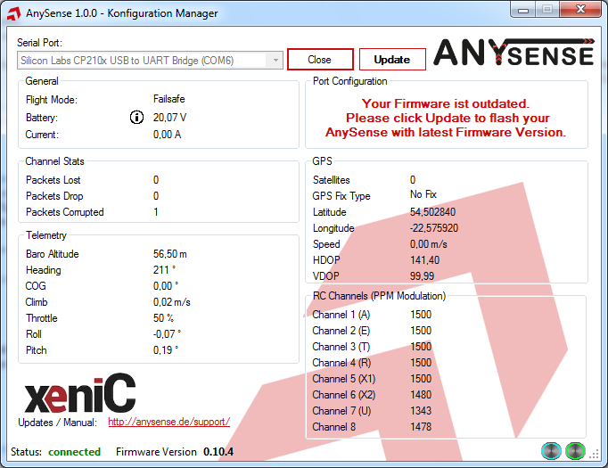

Do not disconnect the connection to AnySense during the update.

After the update process, the settings for the two ports can be carried out as normal. During the update process, the settings will be reset to the condition as originally supplied to the customer.

## Telemetry system

The AnySense has two telemetry ports, which are independent from one another. These are marked as Port 1 and Port 2.

It is possible to define what functions are to be fulfilled by these ports in the Configuration Manager. To do so, open the window for the connection settings using the ‘Configuration’ button, next to the corresponding port, in which the settings for this port can be carried out.

## Futaba S.Bus2

The Futaba telemetry system works with so-called time slots, also simply called slots. A total of 32 slots are available.

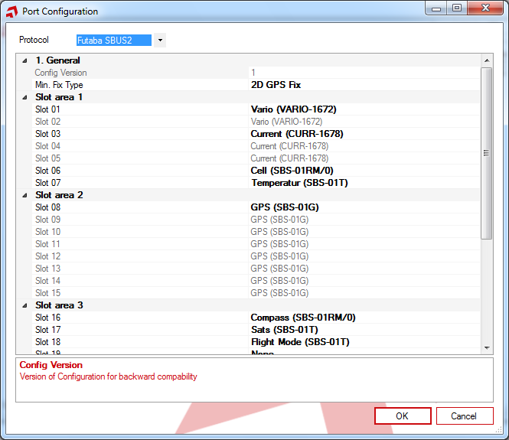Each of these slots can be assigned sensors, which are supplied through the AnySense. As a rule, adjustment is only necessary if sensors are already being operated, thus causing a slot overlap. Thereby the slots that are already occupied by other sensors can be deactivated for the AnySense or can be assigned to other slots.

For example, if slots 1-3 are already occupied by the Futaba CURR-1678 sensor, ‘None’ can be selected from the list in the Configuration Manager for slots 1-3.

Instead the AnySense Vario (VARIO-1672) can be activated now for slot 4.

In the process the AnySense emulates the sensors that are defined in the Configuration Manager and supplies for example for GPS (SBS-01G), the GPS information of the DJI flight controller.

It is thus necessary to also indicate to the transmitter which sensors it can expect to be under which slot in addition to the settings selected here.

Furthermore, the minimum GPS fix type can also be set. The GPS fix determines the quality of the GPS signal. It determines from which level of GPS quality the AnySense GPS-dependent data, such as GPS position, distance, speed, etc. should be supplied.

The higher the GPS fix type, the longer it takes until the first GPS data are transmitted. The lower the GPS fix type, the faster the first GPS data are transmitted; however the data are then more imprecise at the beginning.

## Graupner/SJ HoTT

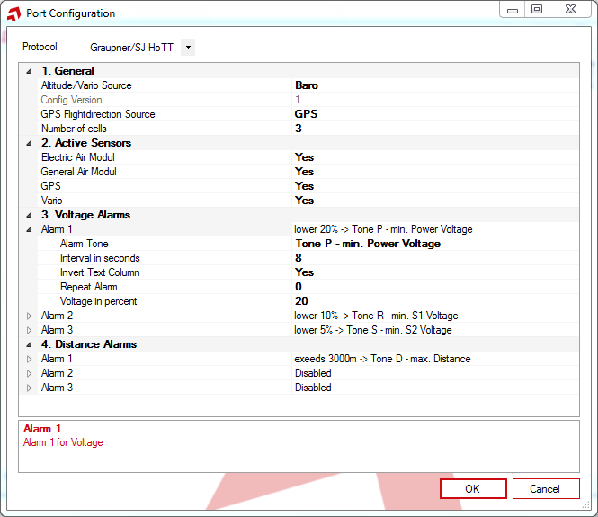In the port settings for Graupner/SJ HoTT, it is possible to set alarms, active sensors and the sources for some telemetry information.

The active sensors are supplied by AnySense. If you already are using a sensor such as the Electric Air module, these entries can be changed to ‘No’ in ‘Active Sensors’.

In this case, the sensors are no longer supplied by AnySense.

Up to three alarms for voltage and three for distance can be set. The alarms are configured as follows and each alarm can be set separately.

Voltage alarm:

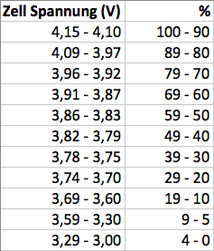**Voltage in percent**: An alarm will be triggered if the voltage falls below this, in percentage terms. In the process, the residual voltage of a cell will be evaluated as depicted.

**Alarm tone**: The tone/message that is to be transmitted if the alarm is triggered.

**Repeat alarm**: The number of repetitions that are to be transmitted for the alarm tone. Enter ‘0’ for infinite.

**Interval in seconds**: Defines the distance between two alarm tones in seconds.

**Invert text column**: Setting option for whether the text for the voltage should be displayed inverted on the transmitter.

Alarm distance

**Distance in metres**: The distance to the home point in metres

which, when exceeded, will trigger an alarm.

The remaining settings for the distance alarm are identical to the voltage alarm.

General settings

**Altitude/Vario source**: Select here the source of the altitude that should be displayed in the telemetry display of your transmitter. Select either the GPS altitude through NN or the barometric altitude.

**GPS flight direction source**: Select here the source of the flight direction that should be displayed in the GPS telemetry display of your transmitter. Select either the GPS-based direction or the compass.

**Number of cells**: Enter here the number of LiPo cells

with which you fly your model.

## Jeti Duplex EX

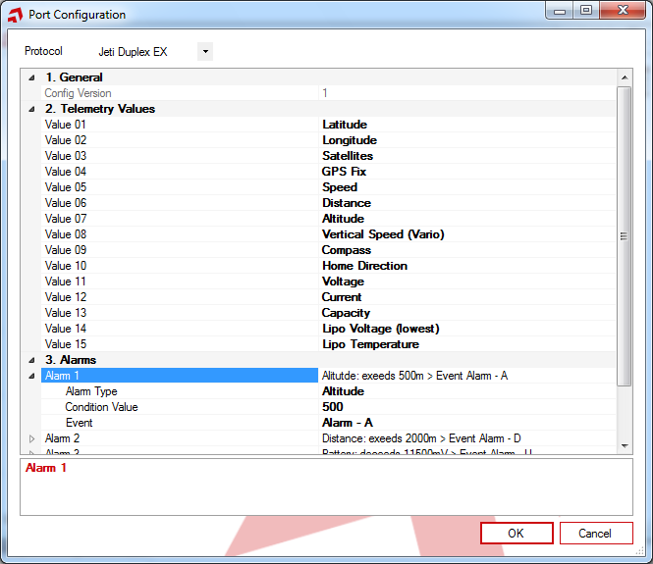The Jeti Duplex EX system allows up to 15 telemetry values to be transmitted. As the AnySense can supply more values, in the standard configuration the telemetry values depicted will be transmitted.

However other telemetry values can also be selected.

In addition, up to six alarms in non-EX process can be output.

This includes setting alarms for voltage, altitude, distance and capacity.

Alarm settings

**Alarm type:** Defines for which telemetry value an alarm should be set.

**Condition value:** The condition that will trigger the alarm. If for example altitude is set as the type of alarm, then the alarm will be triggered when the value that is set here is exceeded.

**Event:** The alarm that will be triggered on the transmitter. It is then possible to set on the transmitter what should happen if this alarm is triggered.

## FrSky S.Port (Taranis)

In the FrSky S.Port port settings, in addition to the general settings, the assignment between the telemetry information provided by AnySense and the FrSky telemetry values can be changed.

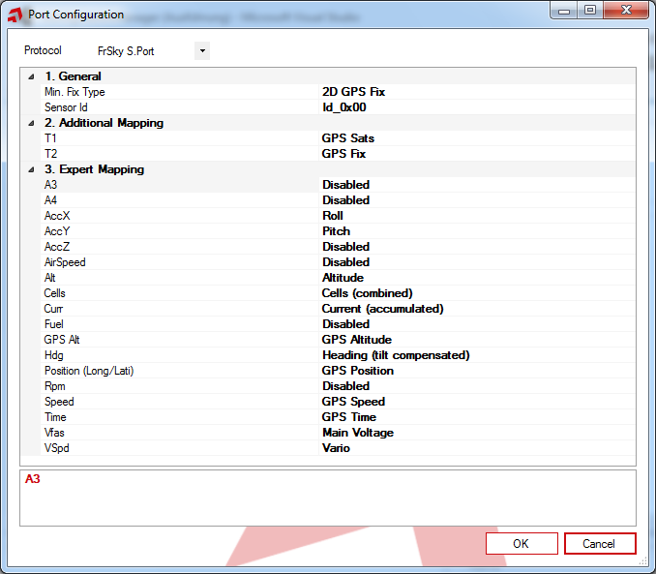

General

The min. fix type makes it possible to define from which GPS level of quality the AnySense GPS-dependent data, such as GPS position, distance, speed, etc., should be transmitted.

The higher the GPS fix type, the longer it takes until the first GPS data are transmitted. The lower the GPS fix type, the faster the first GPS data are transmitted; however the data are then more imprecise at the beginning.

Every connected FrSky S.Port sensor has a unique ID. To avoid overlapping with other sensors, the ID to be used by the AnySense can be specified.

Additional mapping

The Taranis allows individual telemetry views to be created with so-called LUA scripts. To do so, AnySense offers the possibility to assign the measurement values provided by AnySense (right column) to the Taranis telemetry (left column).

Expert mapping

The assignments carried out in this area should only be changed by experienced users.

## Further instructions

## LED status

The AnySense possesses both a green and a red LED for the display status.

The green LED is responsible for the status of the connection between AnySense and the DJI flight controller. A flashing LED signalises data exchange between the AnySense and the DJI flight controller. If the LED is permanently on or off, then there is a problem with the connection to the CAN bus port.

In this case, please check whether you have established the connection as described in Chapter 1 ‘Connection with the DJI’.

The red LED has two functions. For one, it signalises the status of the connection to the telemetry system. To do this, the flashing of the LED signalises the data exchange between the AnySense and the telemetry system.

Its second function is to display the configuration mode. In the first five seconds after being switched on, the LED is continuously illuminated. If a connection has been established with the Configuration Manager, the LED remains continuously on for the duration of the connection.

If the AnySense is not in configuration mode and the LED is nevertheless continuously on or off, this indicates that there is a problem with the connection to the telemetry system.

In this case, please first check whether you have selected the correct telemetry system as described in Chapter 2 ‘Select telemetry system’. If you have selected the right telemetry system, check whether the connection between AnySense and the receiver has been correctly carried out as described in Chapter 3 ‘Connection with the telemetry system’.

1. Only available with the Phantom 2 or additional external sensors. Find out more on the subject of external sensors in Chapter 3 FrSky sensors add-ons. [↑](#footnote-ref-1)